Optimized Mixed Attention-based Bidirectional Gradient Model for Intra-frame Video Forgery Detection
Abstract
Video forgery has become increasingly prevalent with advanced editing tools, posing serious threats to digital media authenticity. However, existing approaches used for detecting manipulations often faced challenges in handling intra-frame forgeries, decreased generalization, sensitivity to noise, and inadequate selection of key frames, thus leading to a decrease in the overall detection performance. To tackle these issues and to design an effective intra-frame forgery detection system, this research proposes an Optimized Multi-level Mixed Attention enabled Hybrid Learning based Bidirectional Gradient (OM²AHL-BiG) Model. The framework leverages the hybrid learning technique to enhance representation of features, Bidirectional Long Short-Term Memory (BiLSTM) for understanding long-range temporal dependencies, and Gradient Boosting Machine (GBM) for precise classification. Additionally, the mixed attention mechanisms allow for refining relevant features, and the Cooperative Search Hunter optimization (CoSH) is designed for hyperparameter tuning in order to improve the detection accuracy. Overall, the OM²AHL-BiG model results in enhanced detection, adaptability to various forgery types, and improved interpretability, making it an effective solution for detecting deepfake and intraframe video forgeries. The experimental results obtained on the FaceForensics++ dataset showcased an improved performance under 90% of training percentage by yielding an accuracy of 98.62%, precision of 99.2%, sensitivity of 98.04%, specificity of 98.91%, and 98.62% F1 score, surpassing conventional approaches effectively.
Keywords: Digital forensics, Intra-frame video forgery detection, Attention mechanism, Hybrid Learning, Deep Learning.
1. Introduction
The increased utilization of deep learning and Generative Adversarial Networks (GANs) for face manipulation has revolutionized the field, enabling the generation of realistic fake videos [1]. In recent years, more sophisticated tools have emerged to manipulate images and videos due to their potential for misuse. The tech companies such as Amazon, Microsoft, and several others have joined hands to organize the Deepfake Detection Challenge (DFDC), aiming to design innovative strategies for identifying deepfake videos [17]. Deepfake means the technology that allows for seamless replacement of a person’s face within video, by creating similar fake content that is difficult for individuals to interpret from real videos [5]. Automated video editing applications, particularly in face manipulation and video tampering, help to swap faces with minimum effort and without the expertise [15]. This technology easily tampers with the original content with another content, without altering expressions or gestures, misleading the audience with visual elements [10]. While these deepfake technologies are designed for dubbing, de-aging actors, and other purposes, they also pose security threats by utilizing this technology for blackmailing, extortion, character assassination, identity theft, and distributing explicit content. These practices can cause severe psychological harm, reputation damage, and social shame. Moreover, in a political background, deepfakes are used to spread misinformation during election campaigns, influencing public opinion [11]. Hence, there is an urgent need to recognize deepfakes in preventing misinformation, fraudulent activities, and the adverse effects of manipulated media [12].
Video forgery involves alteration of digital visual media to produce false or misleading representations. Current detection methods due to the data, lack standardized measures, and narrow focus on a specific type of manipulated frames, leading to inconsistent performance and less generalization [9]. Forgery detection generally targets forged video content through identifying color inconsistencies and semantic irregularities within the frames. The different video sequences are detected on the basis of irregularities in optical flow, motion incoherence, or irregularities across frames. Optical flow-based detection calculates motion fields to identify abnormal behaviors or incoherent movement between frames [3]. Video manipulations can occur in three domains such as intraframe (copy-move), interframe, and spatio-temporal domains [14]. Intraframe forgeries are obtained through duplication of certain regions or splicing around the frame, while interframe forgeries include elimination, shuffling, or duplication of the part of the frame, and hybrid forgeries include combining both [8]. The popular mode of tampering involves deleting or altering the frames, as these are relatively simple to execute. Deepfakes represent a malicious form of activity known as video forgery that causes serious complications such as reputation damage, defamation, stress, and psychological trauma around affected victims, leading to social and economic conflicts [7]. The rapid increase in the development of software tools made creating deepfakes easier without technical expertise, and therefore, designing an efficient technique is crucial to understand the potential misuse [16].
Detection of video forgeries is vital for maintaining the integrity of digital content and ensuring the reliability of evidence across fields such as surveillance, multimedia forensics, and law enforcement bodies [2]. Nevertheless, the digital videos posted on social media can easily be manipulated through editing tools such as Adobe Premiere Pro, Filmora, and other movie-making software by significantly compromising the authenticity of the media [7]. Additionally, forensic methodologies that involve stronger coding in certain frame regions can diminish the visibility of local traces, resulting in incorrect forensic judgments. Existing image-based forgery detection techniques are inadequate for videos due to their complex temporal and contextual dynamics [12]. The prior detection techniques consider forgery detection as a binary classification process, focusing on recognizing artifacts or abnormal features along the frames. However, these methods can be prone to performance degradation and misclassification due to the limited training sample [1]. Early approaches relied on traditional image processing techniques like Discrete Fourier Transform (DFT) [6] and Local Binary Patterns (LBP) but proved ineffective against advanced deepfakes leading to facial inconsistencies, lip-sync anomalies, artifact analysis, shifting the situation towards deep learning to tackle the issue of deepfake videos, prompting the development of robust detection methods [5]. With the increase in sophisticated deepfakes, there is still room for development of a more accurate and resilient approach for identifying the manipulated videos [13].
This research aims to mitigate the existing challenges by developing an OM²AHL-BiG framework to effectively detect intra-frame video forgeries. The detection model comprises diverse forged and authentic videos collected from the benchmark dataset to ensure high variability. The adaptive frame selection and the Viola-Jones-based ROI extraction technique allow for isolating keyframes and region localization, thereby improving processing efficiency. The range of feature extraction GradCAM features, ResNet101-based pretrained statistical features, Hybrid VGG-16 enabled Scale Invariant Feature Transform (SIFT) based features, and the Hybrid shape descriptor enabled ResNet-101-based features enables the framework to extract semantic and structural forgery traits. The system can gain further insights into the forgery behavior using the combined use of incremental and contrastive learning as a hybrid way of learning. Attention mechanisms refine feature relevance, while an integrated optimization strategy ensures precise parameter tuning. Finally, an effective classification layer captures the learned features, yielding high-accuracy predictions on whether a video is genuine or tampered, thus ensuring effective outcomes in detection. The key highlights of the research are described as follows.
- Optimized Multi-level Mixed Attention enabled Hybrid Learning based Bidirectional Gradient (OM²AHL-BiG): The OM²AHL-BiG framework integrates the hybrid learning technique comprising incremental and contrastive learning to prevent catastrophic forgetting and enhance model training. While the BiLSTM allows for capturing long-range temporal dependencies and the multi-level mixed attention ensures refining of relevant features. Additionally, the CoSH optimization boosts hyperparameter tuning and generalization. The classification using GBM replicates the better accuracy, resilience, and interpretability in the detection of intricate patterns of forgeries.
The further parts of the paper are organized in the following way: The literature studies, along with their limitations and problem definition, are carried out in Section 2, The systematic approach is visualized in Section 3, and Section 4 explains the strategies and mechanisms incorporated by the proposed OM²AHL-BiG framework. Section 5 derives the discussion and results. Section 6 finishes with successes and future scopes.
2. Literature Survey
This part elaborates on the literature work used in the topic of video forgery detection is described below.
Fang, M. et al. [1] designed a spatiotemporal Identity Network (STIDNet) for recognizing video forgeries. The framework efficiently captures the forensic clues and improves robustness against video forensics. While tested for validation using diverse datasets depicting forged patterns, showcased as valuable outcomes. However, the approach failed to adapt to different frames and reduced accuracy in certain circumstances of identity. Mazhar, A.A. et al. [2] utilized the Deep Convolutional Neural Networks (DCNN) model to leverage the potential of deep networks to identify video sequence forgeries. The alterations in training, feature extraction from patches increased the stability of object-based forgeries. However, the framework indicated a decline in performance while recognizing low-bitrate and resolution forged videos.
Liu, Q. and Xue, Z. [3] conceptualized the utilization of the Spatio-Temporal Local Feature Abstraction (STLFA) model to detect the facial forgeries tailored to the media environments. The framework analyzed the sophisticated features such as movements, key points, facial corners, and so on to identify the abnormalities introduced in videos. Despite the promising outcomes in the FF+ dataset, the model lacked cross-validation and possessed generalization challenges. Bozkurt, I. and Ulutas, G. [4] suggested the incorporation of a binary template strategy using the feature matrix through Discrete Cosine Transform (DCT) to detect forgeries in manipulated frames. The framework utilizes splitting the frames into subsequent parts to detect frame duplication, otherwise known as intraframe forgery. The severe complication of the model includes detecting fraudulent frames efficiently only at the beginning or end of the frame, which abruptly obscures the performance rate.
Zhang, D. et al. [5] designed a facial forgery system through a pre-trained EfficientNet model. It involves the integration of multiple features for the local enhancement and discrimination of features using the noise and spatial domains. The attention mechanisms improved the feature representation capability, however, the insufficient module for detecting tampering artifacts leads to poor generalization and scalability issues. Cai, Z. et al. [6] designed a Boundary Aware Temporal Forgery Detection (BA-TFD) based on the 3D Convolutional Neural Network (3DCNN) to address the visual manipulations more efficiently. The methodology incorporated the Localized Audio-Visual Deep Fake (LAV-DF) dataset to capture multimodal manipulations. However, the stringent features failed to deliver promising outcomes, whether the frame is forged or normal.
Li, L. et al. [7] introduced a Gray Level of the Co-Occurrence Matrix (GLCM) to analyze the textural features of video frames, which increased the frame duplication accuracy. The statistical descriptors were efficiently concentrated to localize and identify the forged frames. Using the SULFA dataset, the framework outperformed other approaches by an exceptional margin. However, the model suffered while detecting inserted and deleted inter-frames. Bao, Q. et al. [8] introduced a unique approach using the Noise Matrix Analysis for video forgery identification. It includes a pyramid-based approach along with learn module to eliminate the integral group pictures (GOP) frames in the forged videos. However, the model lacks efficiency due to the limited 80 videos allowed for validation, leading to a stringent detection capability.
2.1 Challenges
The challenges that hinder the detection performance of the forgery detection are presented below.
- The STIDNet model [1] lacks discrimination of efficient characteristics from the features, thus leading to an increase in false positives.
- The DCNN framework [2] leads to the misclassification of certain facial forged frames due to the post-processing operations.
- The EfficientNet [5] failed to distinguish between the forged and real videos accurately due to the introduction of noise in the feature distribution, disrupting the performance.
- The GLCM [7] failed to adapt to different frames, misleading the identification of forged frames due to the inaccurate texture findings.
- The limited number of media data included for validation hindered the efficiency of the model and led to biased classification and overfitting issues [8].
2.2 Problem Statement
The evolution of the Internet has paved the way for people to share digital content effortlessly through videos. However, this content may contain fake information which are generated by software tools to manipulate the content just like the original and realistic ones, which may mislead public opinion and cause serious complications across various domains with defaming and ruining the reputation of the person. Therefore, detecting such manipulated media content and forgeries is a pressing need to protect the authenticity and integrity of video evidence. Hence, this research aims to identify authentic and scam videos by designing a forgery detection system. Initially, the system fetches the videos from the FaceForensics++ dataset [30], which contains both forged and authentic videos shared on social media. The dataset ()can be represented as,
(1)
where, implies the video and the corresponding output label, and denotes the total videos. The output labels belongs to for the FaceForensics++ dataset [30] can be denoted as
(2)
Since each video contains multiple frames, the frames present in the video are denoted as,
(3)
where, denotes the frame of the video and indicates the total frames. The following frames are then allowed for the stage of preprocessing to eliminate and select the key frames required for analysis. After this stage, the frames are inserted into the feature extraction process, where a series of features are captured after performing several processes and are represented as . Then, the obtained features determining essential information are passed to the proposed forgery detection model, which then classifies the subsequent video as normal or scam. The model uses supervised contrastive loss to detect the error value, and it is expressed as,
(4)
Here, implies the feature embedding of the anchor frame with index of the predicted label, indicates the loss value for the anchor frame , denotes the feature representation of the positive samples with index indicating same class and implies the feature representation of the negative samples with index indicating different class,implies the cardinality of set of indices of all positives in the multi-viewed batch, and denotes scalar temperature factor.
3. System Model
The detection of video forgeries, especially through intra-frames, involves detecting manipulations within the single frame, such as copy-move forgeries or insertion and deletion of objects. The preliminary process of the detection process begins with collecting diverse video samples posted on social media platforms through the FaceForensics++ dataset [30]. Then, the following frames are allowed into pre-processing to eliminate irrelevant frames and select content-specific frames for processing. The pre-processed frames are then inserted into a module of feature extraction to extract multiple range of features for detecting forgeries. The obtained features are allowed for model training, and upon completion of training, the framework is tested with the test data to determine the effectiveness. Finally, the model reflects the outcome as either normal or scam, and performance evaluation is performed to determine the proficiency in detecting forged videos. The systematic approach of the proposed forgery detection system is illustrated in Figure 1.
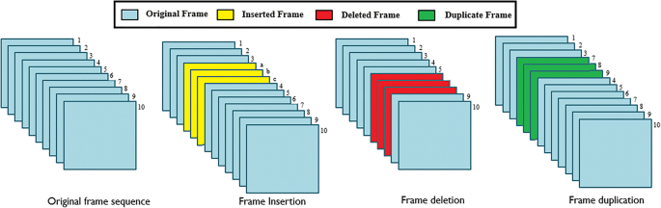















Video manipulation
Videos from multiple sources
Collection of Digital Videos
Preprocessing and ROI Extraction through frames
Feature extraction
Train frame features
Test frame features
Model Training
Trained Model
Evaluation of Performance
Normal
Scam

Figure 1. System Model for the Detection of Video Forgery
4. Proposed Optimized Multi-level Mixed Attention enabled Hybrid Learning based Bidirectional Gradient Model for Intraframe Video Forgery Detection
The increased utilization of editing tools has paved the way for effortless manipulation of digital content, thereby spreading misinformation, damaging reputations, and creating social conflicts. Moreover, in law enforcement bodies, videos are presented in the form of videos. Hence, there is an increased demand for detecting such tampered and forged frames efficiently; therefore, this research strives to develop an OM²AHL-BiG framework that is capable of detecting intra-frame forgeries accurately. The methodology begins with collecting video frames through the FaceForensics++ dataset [30], containing both forged and authentic videos collected from diverse sources such as political, celebrities, social media, news, and many other platforms. These videos are inserted to perform pre-processing, where the adaptive frame selection strategy is employed to select the key frames of the video that depict suspected forgeries. Then, a Viola-Jones strategy is applied for ROI extraction to capture regions of faces. Then, the processed frames undergo a process of feature extraction where the complex characteristics of the forgeries are captured. This process includes GradCAM, ResNet101-based pretrained statistical features, Hybrid VGG-16 enabled SIFT-based features, and the Hybrid shape descriptor enabled ResNet-101-based features. The features are then fed to the OM²AHL-BiG framework for training, which comprises Hybrid learning of Incremental and Contrastive learning for learning feature representations more accurately, BiLSTM for capturing long-time dependencies, and GBM for classification. Additionally, the attention mechanisms and the CoSH optimization allow for discriminating abstractive features and efficiently optimize hyperparameters to increase prediction accuracy. Finally, the test frames are utilized to test the framework, and the outcome can be derived as normal or a scam. The schematic illustration of the OM²AHL-BiG is presented in Figure 2.





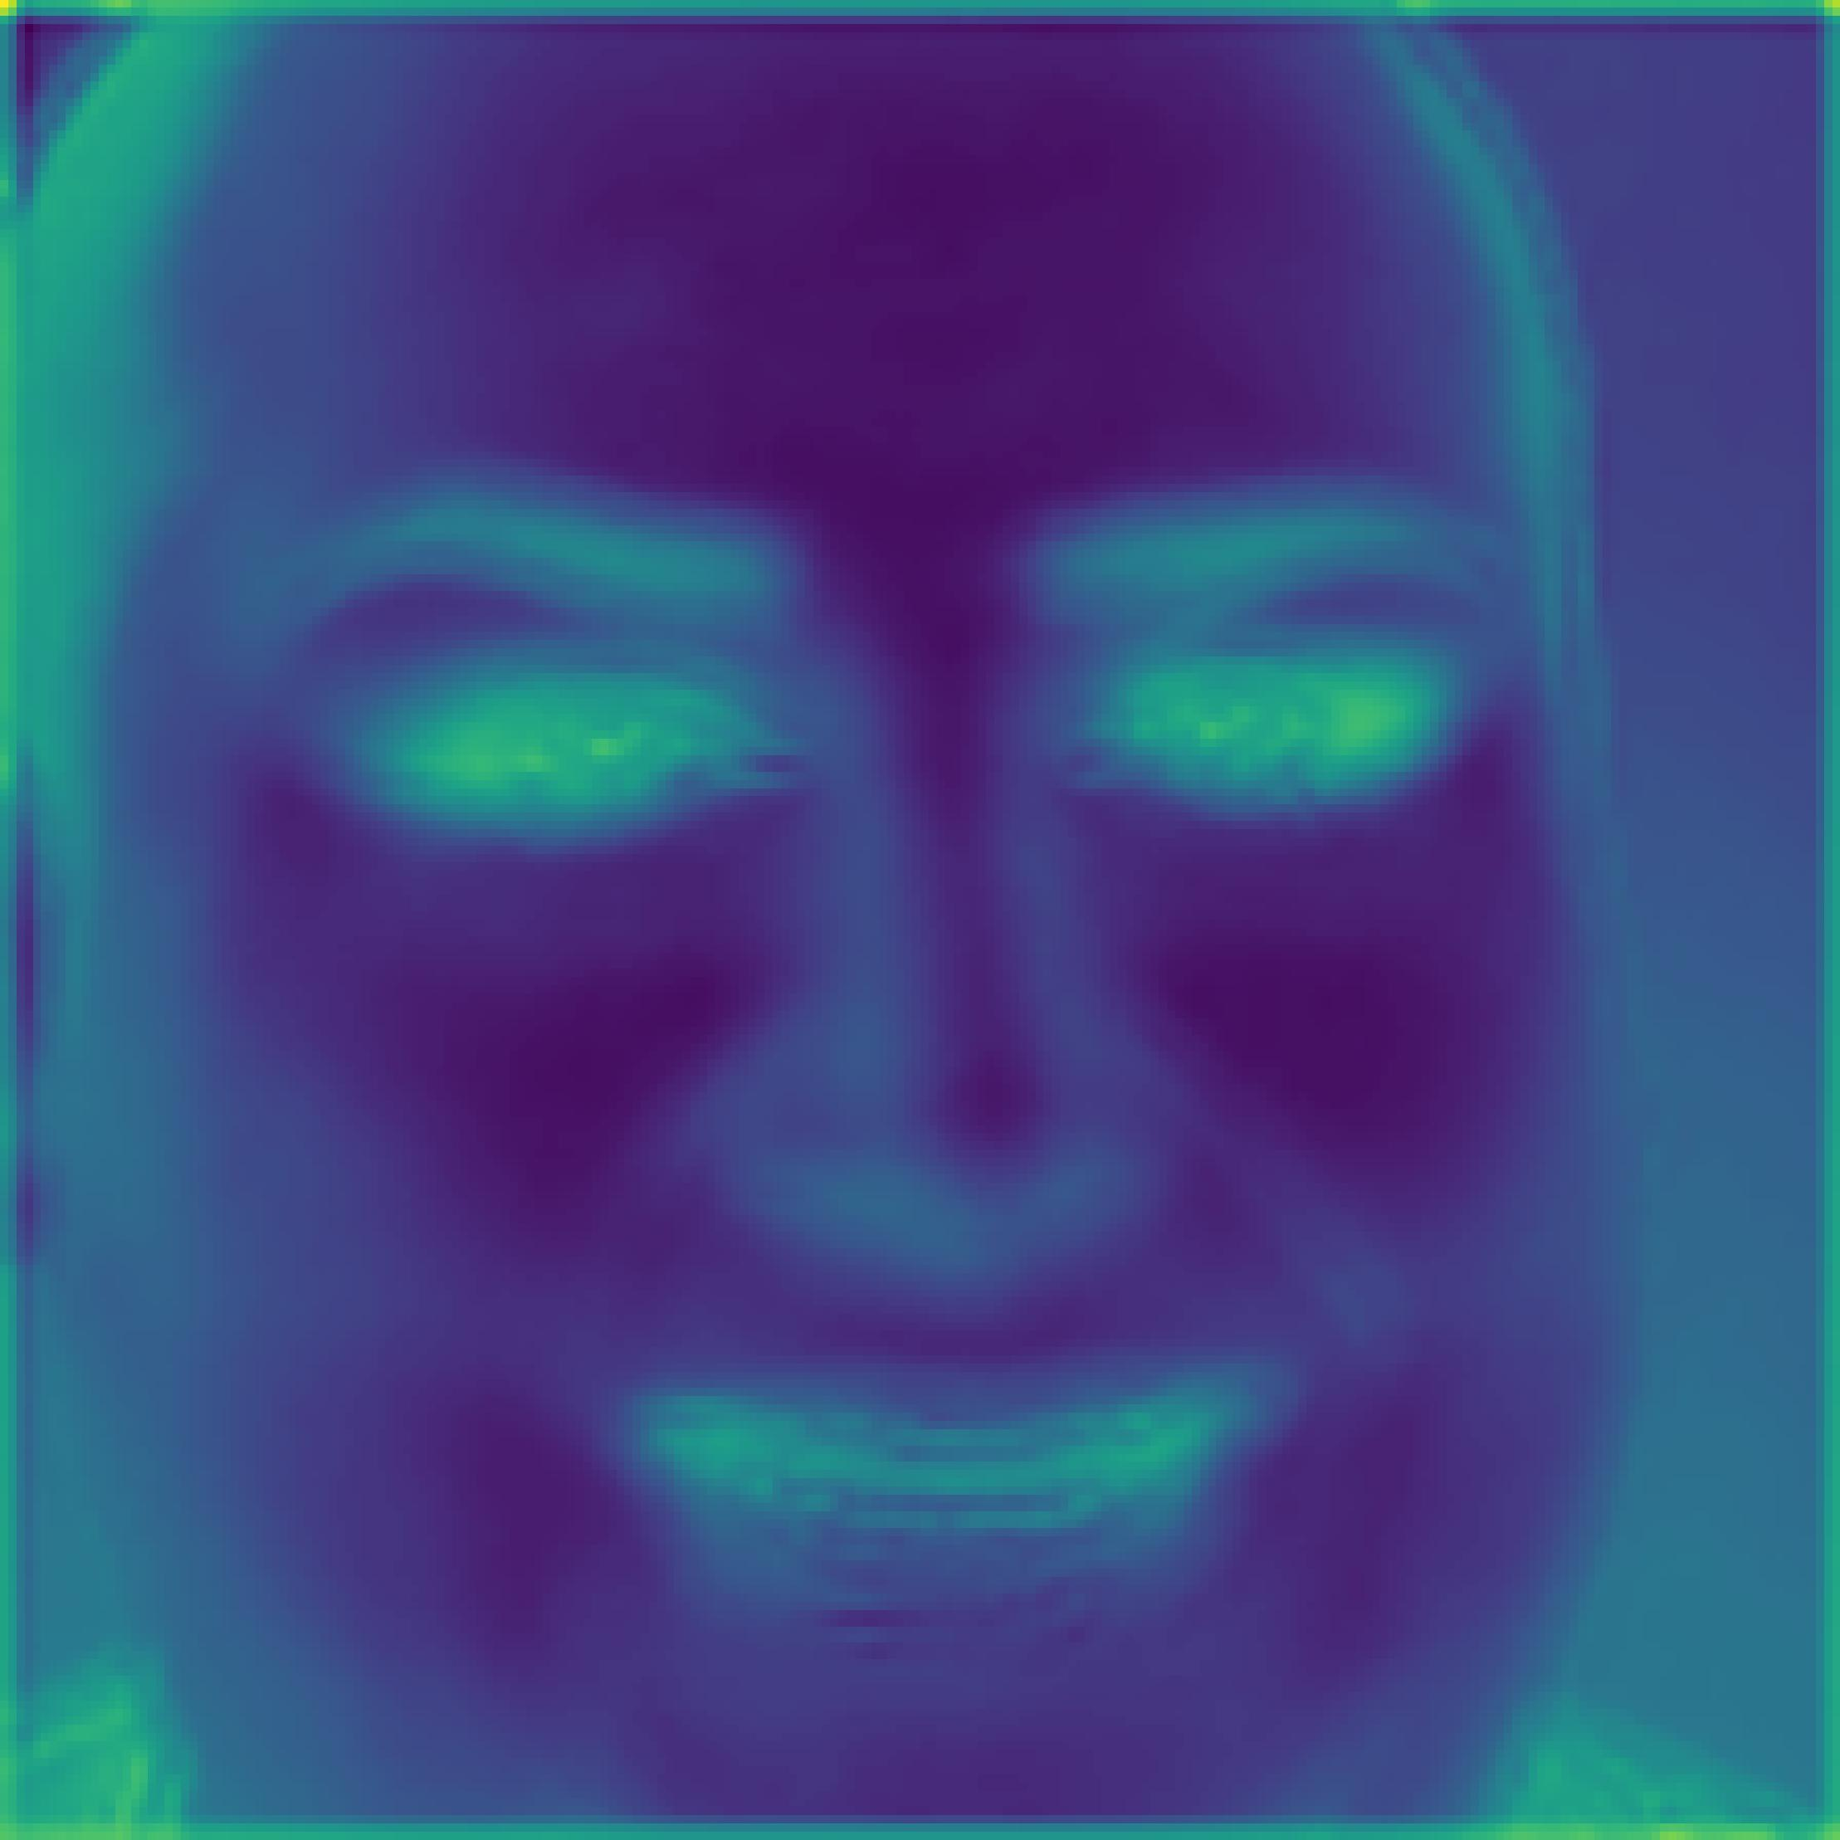


Input Video frames
FaceForensics++ dataset
Adaptive Frame Selection
Viola Jones based ROI Extraction
Pre-processing
-GradCAM features

-ResNet-101 based Statistical features

-Hybrid VGG-16 enabled Scale Invariant feature transform-based features

- Hybrid shape descriptor enabled ResNet-101 based features

Feature Extraction
CoSH Optimization
Multi-level Mixed Attention
Test data
Optimized Multi-level Mixed Attention enabled Hybrid Learning based Bidirectional Gradient Model
Trained model
Normal
Scam
Output

Figure 2. Schematic diagram of the OM²AHL-BiG Framework
4.1 Input Video Data
The intra-frame video forgery detection process starts with the collection of video frames from the FaceForensics++ dataset [30], determining both forged and normal videos. Each video contains multiple frames, and these frames are utilized further for the detection process. The representation of the dataset and frames is expressed in equations (1) and (3), from which the videoof total frames is allowed to pre-processing.
4.2 Preprocessing of Video Data
During this stage, the Adaptive Key frame selection is utilized to select only the keyframes from the videos, and the Viola Jones based ROI extraction is used to select the particular regions of the facial edges irrespective of their shape, surroundings, or volume, and the brief description is elaborated below.
4.2.1 Adaptive Key Frame Selection
The adaptive key frame selection [18] involves extracting representative frames from a video sequence using the Extreme Studentized Deviate Test (ESD) and the Relative Entropy (RE) and. Initially, the video is partitioned into shot sequences by ESD, then every shot is divided into multiple sub-shots. From every subshot, a key-frame is selected based on whether the content deviates large or small. This method is especially beneficial because it dynamically identifies frames that contain significant scene or motion changes, making them more likely to capture instances of tampering such as frame duplication, splicing, or insertion compared to conventional wavelet-based approaches, which decrease the volume of data and produce the same information. By isolating these informative frames, the algorithm significantly reduces redundant data while preserving the contextual integrity required for accurate forgery analysis. The pre-processed frame can be expressed as , which further undergoes ROI extraction.
4.2.2 ROI Extraction through ROI Extraction
The Viola-Jones-based ROI extraction method [19] has been mainly focused on the detection and localization of objects like faces or other facial features of human beings within video frames. The Viola-Jones acts as a classifier that employs Haar-like features and a cascade of classifiers called the Adaboost, allowing it to detect ROIs with minimal false positives. The Adaboost classifier obtains the most selective regions by combining the weak classifiers together to form a single representation of region-specific outcome-determining forgeries. The ROI extracted can be denoted as,
(5)
Here, implies the ROI extracted outcome determining a dimension of in which denotes videos and denotes the total frames, denotes the weak classifier at the stage from the key frames , denotes the weights, and implies the total number of classifier stages. When dealing with the forged videos where manipulations are usually localized and not conspicuous, using consistent ROIs allows training and testing the model on the most informative and vulnerable zones. The viability of employing Viola-Jones ROI extraction rests on the fact that it is efficient and effectively reliable in extracting potential areas where the forgery is most likely to occur, like the facial region in the deepfake video or face-swap video. By focusing only on these significant regions, the method reduces the amount of irrelevant data and noise that could mislead the detection model, thus decreasing the computational burden and accuracy by minimizing the size of the input.
4.3 Feature Extraction of Frames
In video forgery detection, feature extraction is essential for identifying the tampering or manipulation in frames by capturing the essential characteristics. The range of features such as GradCAM features for visual interpretability, ResNet-101-based Statistical features to extract high-level semantics using deep residual learning, Hybrid VGG-16-enabled SIFT-based features for capturing spatial hierarchies, and Hybrid shape descriptor-enabled ResNet-101-based features for enhancing structural contour sensitivity. The extracted features through the pre-processed frames are briefly described in the upcoming section.
4.3.1 GradCAM features
Grad-CAM is a strategy utilized to capture the visual attention-based features by highlighting the regions that are most discriminative for forgery, providing spatial evidence of tampering. The Grad-CAM [20] generates heat maps for the CNN classification network. These heatmaps emphasize important parts of the image or video frame that greatly influence the decision. It computes gradients of the class score to measure the area under the output score with the final layers of the network. Let the class gradient corresponding to the activation layer can be denoted as
(6)
where, implies the spatial dimensions. These gradients are reduced across spatial dimensions to generate importance weights represented as .
(7)
where, denotes the ROI extracted outcome with gradient “”, denotes the feature map. The outcome of the final layers is reduced using the importance weights to obtain a final heatmap expressed as,
(8)
Here, implies the GradCAM enabled heatmap of dimension that helps to localize regions of manipulation, such as duplicated objects, by conceptualizing the model’s focus during classification
4.3.2 ResNet-101-based Statistical features
The pre-trained ResNet-101 model is utilized to capture high-level features from the pre-processed frames. This architecture includes as input and using residual learning discards the vanishing gradient issue, thereby allowing for understanding complex textures, edges, and inconsistencies across the frames. The outcome gathered from the ResNet-101 layer can be denoted as . This feature outcome is further processed to statistical measures [21] like mean, standard deviation, variance, Kurtosis, and Skewness to summarize the discriminative characteristics from the frames required for detecting forged regions. The description of the statistical features, along with their formulation, is presented in Table 1.
Table 1. Statistical Analysis
Statistical measures | Definition | Formulation | Dimension
Mean | Measures the average rate from the obtained feature map | -Mean, -total elements, -single feature element, - ResNet-101 outcome
Standard deviation (SD) | A measure of the dispersion rate around the mean. | -Standard deviation
Variance | It is obtained by the square root of the SD that determines the rate of feature map dispersion. | -Variance
Skewness | It evaluates the range of asymmetry distribution in the feature map. | -Skewness
Kurtosis | It computes the textural outliers present in the map. | -Kurtosis
The obtained statistical measures are allowed for concatenation to obtain a single vector representation that can be represented as.
(9)
where denotes ResNet-101 based statistical feature determining a dimension of .
4.3.3 Hybrid VGG-16 enabled Scale Invariant feature transform-based features
The VGG-16 is a pre-trained deep CNN framework that is applied in this process to capture the global semantic features from the pre-processed frames . It applies 13 convolution filters and the three fully connected layers to inherit the complex textural and pattern-like features. On the other hand, the SIFT [22] is a feature descriptor technique that extracts local invariant features such as scale and rotation-based invariants, making it especially useful in video forgery detection where tampered regions might be resized, rotated, or modified over time. This hybrid strategy benefits from both learned deep representations and precise local descriptors, enhancing the ability to detect a wide range of forgeries. The SIFT allows the detection of features at multiple scales. Consider a frame , the algorithm detects key points using the Difference of Gaussian (DoG) represented as,
(10)
(11)
(12)
where, implies the Gaussian filter with pixels under scale , denotes the scale-space extrema, denotes the constant multiplicative factor, and denotes the scale of observation. Then, each detected key point utilizes a 128-bit descriptor, assigned with gradient orientations. Then the key points are allowed into VGG-16 to obtain a feature map denoted as with dimension .
4.3.4 Hybrid shape descriptor enabled ResNet-101-based features
The Shape descriptor based on Canny edge detection [23] combined with the ResNet-101 model allows for capturing structural boundaries and the temporal inconsistencies introduced by forgery operations, such as unnatural transitions, blur artifacts, or frame irregularities. The preprocessed outcome is passed as input, determining a grayscale frame with pixels , and the gradient magnitude is computed initially through the Sobel operator denoted as,
(13)
(14)
(15)
where, and denotes gradient magnitude and angle, and , denotes the horizontal and vertical gradients. Then, non-maximum suppression and hysteresis thresholding are applied to retain meaningful edges. The resulting binary edge map becomes the shape descriptor input. Then, ResNet-101 comprises 101 layers with a deep residual network that allows for capturing hierarchical patterns through skip connections. By embedding the Canny edge-based descriptor into the ResNet-101, the model gains the ability to capture both semantic and shape-level discrepancies, making the extracted features more robust and informative for forgery classification. The features obtained under this stage can be signified asof size.
The following features obtained are concatenated to form a single vector expressed as,
(16)
where, implies the final features of size, which is further allowed to the OM²AHL-BiG model.
4.4 Optimized Multi-level Mixed Attention enabled Hybrid Learning based Bidirectional Gradient Model
The OM²AHL-BiG proposed in this research integrates Hybrid Learning, BiLSTM network, GBM classification, along with the attention mechanism and optimization approaches to accurately identify intra-frame forgeries. The proposed framework initially allows a vector of size into the model. The following input dimension is reshaped through concatenating the features and the frame feature dimensions to obtain a three dimension of . The reshaped input is forwarded to the BiLSTM layer of size to detect patterns from both forward and backward sequences, making it sensitive to the disruptions in the frames. Then, an activation and dropout layer are applied to introduce non-linearity and prevent overfitting. Then a BiLSTM of size is applied to further capture the inherent dependencies of the model. Moreover, the OM²AHL-BiG architecture utilizes a hybrid learning strategy to efficiently train the model, thus making it adaptive to evolving manipulation techniques. The detailed explanation of the hybrid learning and the BiLSTM is explained in the later sections. The architecture of the OM²AHL-BiG framework is portrayed in Figure 3.
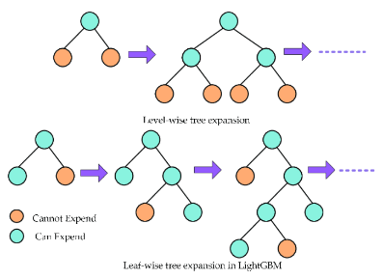
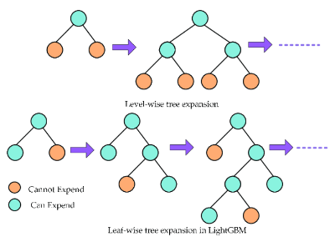
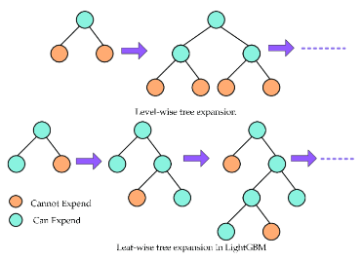
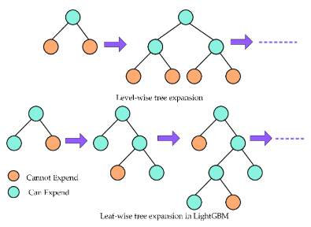

…
Predicted Outcome
Input
Multi-level Mixed Attention

Mutual Cross Attention
Sparse Self Attention
Channel Attention
Zero Attention
Gradient Boosting Machine
Tree 1
Tree 2
Tree N
Normal
Scam
-BiLSTM layer
-Activation (ReLU)
-Dropout layer
-Reshape
CoSH Optimization

Figure 3. Architecture of the OM²AHL-BiG Framework
4.4.1 Hybrid Learning
The OM²AHL-BiG framework employs a hybrid learning approach combining the Incremental Learning and Contrastive learning to allow continuous learning along with strong feature discrimination. The Incremental learning [24] initially partitions the features into multiple tasks, denoted as to learn the features iteratively with the previously gained knowledge. This strategy allows the model to adapt to newly arrived forged frames without forgetting previous knowledge, commonly known as catastrophic forgetting. When a new set of forged data incremental learning enables the model to update its knowledge base continuously, by updating the model parameter for the task can be denoted as,
(17)
where, implies the feature vector, denotes the observation context space, anddenotes context outcome. To prevent forgetting and to retain knowledge, a regularization term is added to the loss, which can be represented as,
(18)
where, implies the loss factor, denotes the loss on the new task, implies the current parameters of the model and denotes the previous parameters learned through the old task,denotes the Fisher information matrix, and denotes the regularization strength. While the Contrastive Learning is a self-supervised learning paradigm that allows to learn discriminative features by comparing similar and dissimilar pairs. The contrastive loss is represented in equation (4), which allows to learn similar positive frames, either normal or forged frames, closer while dissimilar frames apart. In video forgery detection, contrastive learning is valuable because forged and authentic frames may share subtle differences that are hard to detect using traditional supervised learning, especially when labeled data is scarce. In video forgery detection, through hybrid learning approach that integrates contrastive and incremental learning provides a powerful and adaptive framework capable of addressing forged frames more accurately through learning.
4.4.2 Bidirectional Long Short-Term Memory
The BiLSTM, a recurrent network variant, extracts both the past and the future relations in the sequential data. Unlike standard LSTM networks, which process sequences in a single forward direction from past to present, BiLSTM [25] processes the data flow directions both in backward and forward, making it more effective at detecting bidirectional inconsistencies caused by temporal manipulations in video sequences. The BiLSTM performs similar LSTM operations at each time step . It comprises two LSTM cells, where one cell processes the sequence from forward from and the other from backward . The BiLSTM for every time step, using both the LSTM cell, measures hidden state and utilizes the input and previous state of hidden and memory, the updation can be denoted as,
(19)
(20)
(21)
where, and implies the hidden states of forward and backward direction, and implies the feature vector at the timestep . The outcome determines the combined hidden state of both directions at the timestep. The outcome from the BiLSTM of size is forwarded to the Multilevel attention mechanism.
4.4.3 Multi-level Mixed Attention
The OM²AHL-BiG model incorporates multi-level mixed attention comprising mutual cross attention [26] and sparse self-attention [27] after the BiLSTM layers. Then, a Channel attention [28] and zero attention [29] are applied at the next level. The Mutual Attention detects inconsistencies across frames helpful for identifying copied or re-sequenced segments. While the Sparse Self-Attention detects fine-grained irregularities within frames, ideal for spotting spliced or locally altered regions. Initially, the outcome from the BiLSTM is passed to mutual cross attention [26], which then distributes the inputs and passes to multi-head cross attention, where it generates key , query , and value matrices determined as,
(22)
(23)
(24)
where,,, and implies the weight matrices for the query, key, and values. The attention weights are computed are then measured using the scaled dot product attention, denoted as,
(25)
Here denotes the attention weight and implies the dimensionality factor. The mutual cross-attention score can be computed as,
(26)
This mechanism allows to attend to forged frames accurately by highlighting the inconsistencies in the features. While Sparse self-attention [27] reduces redundancy by only allowing attention over nearby or key learned positions by computing similar self-attention using key, query, and values by defining a sparse dot product attention such that only selected positions are attended. This strategy enables to detection of local manipulations like frame insertion and removal that affect temporal locality. The outcome from the sparse self-attention can be expressed as of size .
The outcome is reshaped to and is distributed to the mixed attention strategies comprising channel attention and zero attention to strengthen the model’s feature selection capacity, thereby helping the model to focus on subtle artifacts. The channel attention module [28] consists of max pooling () and global average () alongside the shared multi-level perceptron () to obtain a channel-attention map which can be denoted as,
(27)
(28)
(29)
whereand denotes the height and weight implies the spatial dimensions, denotes the channel attention map with a dimension
On the other hand, a zero attention [29] comprises two different attentions, like Zero Spatial Attention (ZSA) and the Zero Channel Attention (ZCA). The ZSA and ZCA apply max and average pool, followed by sigmoid to obtain the ZCA map and the ZSA map . Then, both the maps using concatenation form a zero-attention map, signified as of size. Unlike standard attention mechanisms, zero attention applies a thresholding or gating approach, allowing the model to ignore zero-value or low-importance activations. Figure 4 depicts the schematic representation of the multilevel mixed attention.

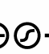
Reshape

Multi-cross attention
Multi-cross attention

Key
Query
Value
Sparse Dot Product attention
softmax

Maxpool
Avgpool
MLP

ZSA

ZCA

Zero Attention

Channel Attention

Sparse Self Attention

Mutual Cross Attention

Figure 4. Overview of Multi-level Mixed Attention
The zero attention and the channel attention are added to obtain a single-dimensional attentional map determining a size , which is then reshaped into . Then an activation and dropout of size is applied to understand complex patterns and overcome overfitting. Following this, a BiLSTM of size is incorporated to extract the time dependency factors analyzed after the discrimination of features. Finally, a GBM model is utilized as a classification model, which is explained in Section 4.4.4.
4.4.4 Classification using Gradient Boosting Machine
GBM is a strong ensemble learning approach employed in both classification and regression problems. The GBM [31] can be used as the final classifier in the video forgery detection task since it is very robust and is capable of modelling complex feature space. GBM operates in the concept of boosting, such that a range of weak learners, like a decision tree, get iterative training. GBM operates in a sequential approach as each new tree is trained to correct the error obtained on the previous ensemble of trees, whose loss is minimized by applying a gradient descent method. This iterative technique allows GBM to extract varied patterns in the data, enabling it to perform tasks where subtle distinctions and non-linearities are observed. Every new tree gets trained to solve the mistakes of the existing ensemble by minimizing the loss function expressed in equation (4). This results in an outcome with improved accuracy and reduced bias. Furthermore, the possibility to obtain the scores of feature importance in GBM allows perceiving which forgery-related features contribute most to the final decision, enhancing the explainability of the model.
4.5 Cooperative Search Hunter Optimization
The CoSH optimization introduced for optimizing the hyperparameters is inherited from the Bald Eagle Search (BES) algorithm [32] and the Harris Hawks Optimization (HHO) [33]. The characteristics of bald eagles excel in global search, while the cooperative hunting strategy of the Harris hawk leads to strong exploitation capabilities. The combination of both strategies allows the optimizer to converge quickly and precisely around optimal solutions. The CoSH optimization is applied after the third BiLSTM layer.
Inspiration: The inspiration behind CoSH optimization is the foraging behavior of bald eagles and the cooperative hunting strategies of Harris hawks. The searching capability of bald eagles through strategic encircling and swooping through flight patterns allows them to explore high-dimensional search spaces effectively. The cooperative hunting strategies of Harris hawks exhibit dynamic adaptive attack patterns and rapid convergence through local refinement. Together, this integration allows for avoiding premature convergence and enhances the model’s robustness in detecting forgeries more effectively.
a) Initialization
Consider a population consisting of random solutions which can be mathematically represented as,
(30)
(31)
where, denotes the starting position of the solution with dimension, and implies the lower and upper bounds in the search space, denotes the maximum solution in population, indicates a random value, and implies the highest search space dimension.
b) Fitness Evaluation
At every iteration, the rate of fitness is calculated for each solution to measure how well a candidate solution performs.
(32)
Here, implies the fitness measure. The maximum accuracy results in a high probability of attaining an optimal solution.
c) Determine Energy factor
The energy factor “” is initialized according to the behavior of Harris hawk in searching prey, and based on the energy consumed during searching and grasping, is modeled as the initial factor essential for finding the optimal solution.
(33)
(34)
where, implies the flight power, indicates the initial power with randomness , refers to a random value in , and implies the current and maximum iteration.
Phase (i): Preliminary Search Phase
This phase executes as an initial step without any condition based on the characteristic of the bald eagle to select the best area initially to search for food within the search area is utilized as a preliminary stage for searching and is modelled as,
(35)
where, represents the best solution at the iteration,denotes the mean position vector,implies current position,indicates a control parameter between 1.5 and 2, and represents the random number in . This equation mainly depends on the best and mean of all solutions, causing premature convergence. Therefore, to enhance the diversity of search, the position can be updated as,
(36)
where, depicts the randomly selected solution, depicts the attained optimal solution at the current iteration. The variables ,,,and implies randomness in the . To increase the explore region and to escape trapping in local optima, the equations (35) and (36) are hybridized as,
(37)

Phase (ii): Strategic Orientation Phase
The following phase executes after the preliminary phase, with the conditions based on the energy factor.
Case (i): Spiral Search-based Updation Phase
The spiral search capability of bald eagles accelerates the search by dynamically adjusting of radius within the search space according to the energy factor expressed as,
(38)
where,
, (39)
(40)
(41)
Here, denotes a point search parameter between , implies the consonant in the range , and denotes the update value based on the spiral pattern, and implies a random value along .
Case (ii)Intensified Refinement Phase
The following phase derives the bald eagle's swooping characteristic to obtain the target solution by jumping from the best position. The rule for position update can be represented as,
(42)
where,
, (43)
(44)
(45)
The following equations replicate that all the points move towards the best point and may get stuck in stagnation. Hence, the soft besiege attack strategy is utilized to attain sufficient power using the Levy flight pattern and is expressed as,
(46)
where, denotes the dimension, refers to the random vector, represents the Levy flight pattern measured as where denotes random variables, and indicates the fixed variable set to .
(47)
(48)
Here, represents the random jump and denotes the random number in the range .
Sub Case (i): Energy Guided Updation Phase
The phase gets executed when the levy flight-based energy factor condition is satisfied. The algorithm utilizing the energy factor introduces stochastic jumps along the search space, thereby leading to stable convergence. The update rule can be expressed as,
(49)
(50)
Sub Case (ii): Levy-based enhanced Refinement Phase
This phase, through levy flight patterns, introduces occasional jumps, thus preventing premature convergence near optimal solutions, and the existing character of direct movement towards the best solution leads to fast convergence. The hybridized equations from (42) and (46) can be denoted as,
(51)
d) Termination
The CoSH optimization after obtaining refined solutions across iterations gets terminated or when the specified number of iterations with the best solution is met. Figure 5. illustrates a flowchart representation of the CoSH optimization.

Start
Generate initial population
Set initial parameter
Calculate Fitness value
Compute Energy factor
Preliminary Phase
Return best solution
End
Phase (i)
Phase (ii)
Yes
No
Yes
No
Yes
No

Figure 5. Flow Chart of CoSH Optimization
5. Results
This section explains the results and comparison of the OM²AHL-BiG framework under various analyses.
5.1 Experimental Setup
The Windows 11 system is used for an experiment that is equipped with 16GB RAM and 100GB ROM, utilizing a Python Tool that includes TensorFlow, PyTorch, and Keras packages. Moreover, the overview of the hyperparameters is described in Table 2. During the postdoc implementation verification (August 2026), the same pipeline was re-executed on Windows 11 with the VideoForgeryCPU conda environment (Python 3.8.20, TensorFlow 2.10, Keras 2.10, CPU-only). Pre-extracted features (199 videos) were loaded via ReadDataset(exec=False). Automated driver commands regenerated analysis plots, drove the customtkinter GUI stages, and performed a smoke-scale training-percentage sweep of OM2AHL-BiG (Section 5.13). A Render-oriented Flask web application under webapp/ exposes the same conceptual pipeline stages in a browser.
Table 2. Hyperparameters
Hyperparameters | Values
Batch size | 32
Optimizer | Adam
Learning rate | 0.01
Activation function | ReLU
Dropout rate | 0.5
Number of BiLSTM layers | 3
BiLSTM Units | (100,128,128)
Loss function | Contrastive Loss
Population Size | 50
Fitness | Accuracy
Number of Estimators | 100
Maximum depth | 1

5.2 Dataset Description
The proposed OM²AHL-BiG framework is experimented with the FaceForensics++ dataset [30]. The benchmark provides DeepFakes, FaceSwap, NeuralTextures and Face2Face manipulations at three compression levels; this work uses the FaceSwap subset at the c23 (high-quality) compression level, paired with an equal number of pristine videos from the original YouTube sequences. It provides a wide range of instances for data-driven forgery detection analysis. The dataset distribution based on the classes is provided in Figure 6.

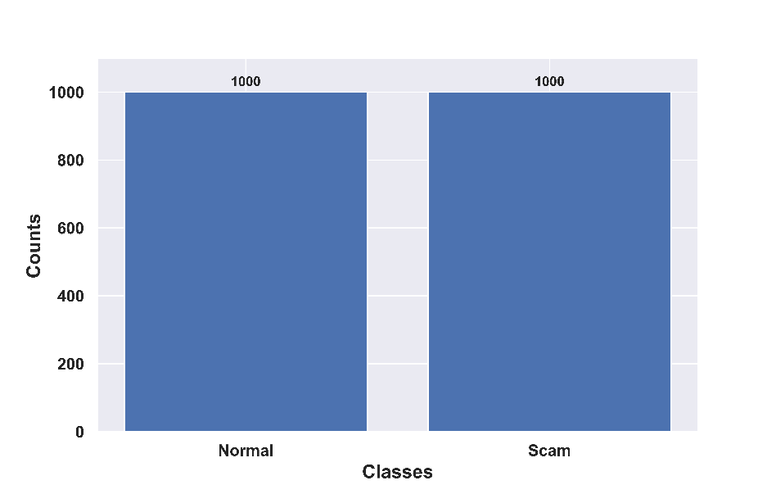

Figure 6. Dataset Distribution
5.3 Evaluation Measures
The metrics used for evaluating the performance of the OM²AHL-BiG framework are signified with their formulation in Table 3.
Table 3. Evaluation Measures
Metrics | Expression
Accuracy | ,- positive and negative instances that are true ,- positive and negative instances that are false.
Sensitivity
Specificity
Precision
F1 Score

5.4 Experimental Results
The sample results analyzed for detecting intraframe video forgeries using the Face Forensics++ are provided in Figure 7.
 | Frame-1 | Frame-2 | Frame-3 | Frame-4
Input frame |  | 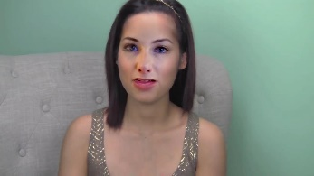 |  | 
Preprocessed frame | 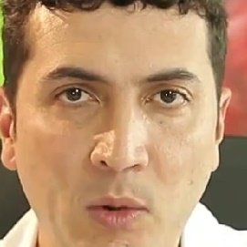 | 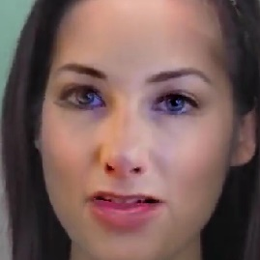 | 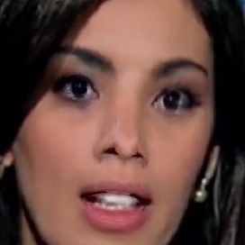 | 
Grad-CAM features |  | 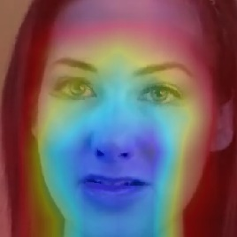 | 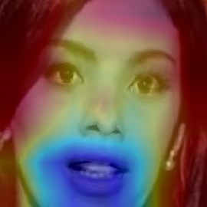 | 
ResNet-101-based features | 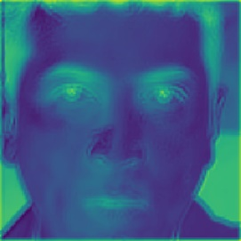 | 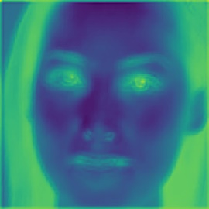 | 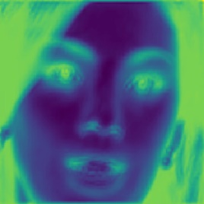 | 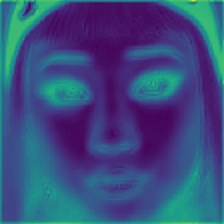
Mean | 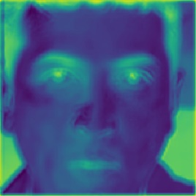 | 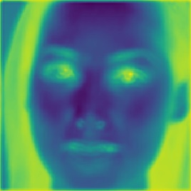 | 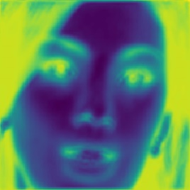 | 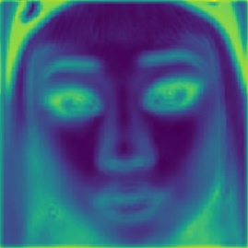
Variance | 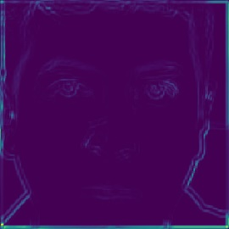 | 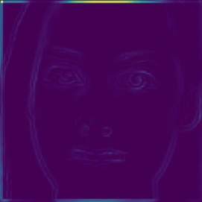 |  | 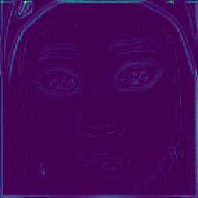
Standard deviation |  | 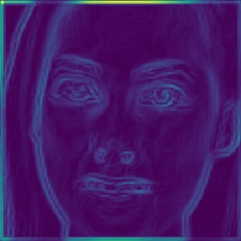 |  | 
Skewness | 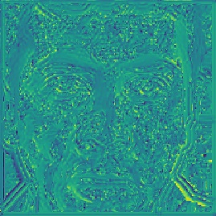 | 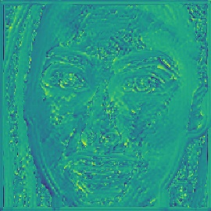 | 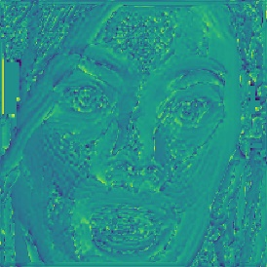 | 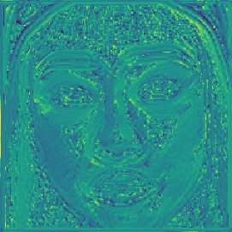
Kurtosis | 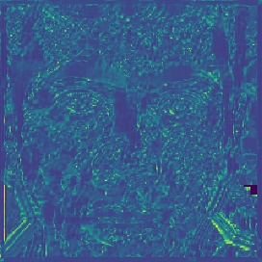 | 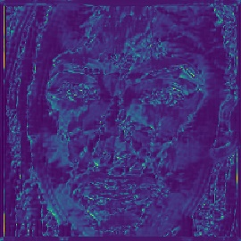 | 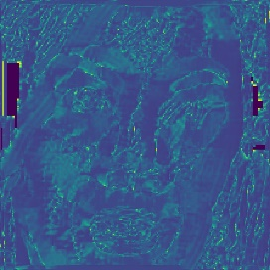 | 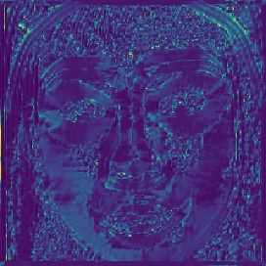
SIFT features | 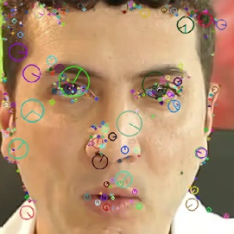 |  | 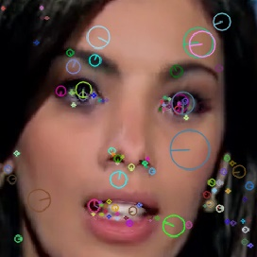 | 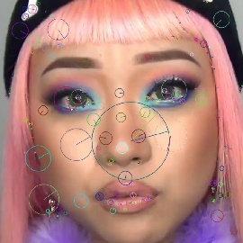
VGG-16-based features |  | 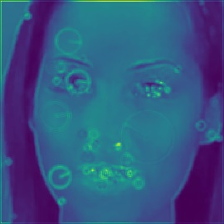  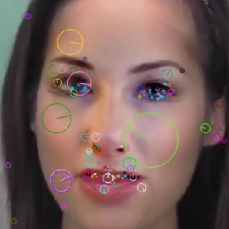 |  | 
Shape descriptor-based features |  |  |  | 
Shape ResNet-101 features | 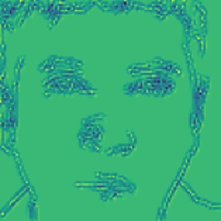 |  |  | 
Output image |  | 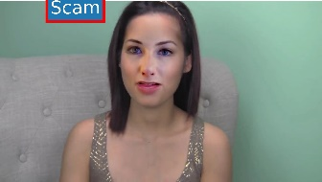 |  | 
Figure 7. Experimental results obtained by OM²AHL-BiG using the FaceForensics++ dataset
5.5 Performance Analysis
This part describes the performance results obtained on the FaceForensics++ dataset under training percentage and k-fold validations.
5.5.1 Evaluation of performance based on Training Percentage through FaceForensics++ dataset
The performance of the proposed framework is tested with the FaceForensics++ dataset, along the training percentage across various epochs is illustrated in Figure 8. The moderate accuracy and F1-score at 100 epochs obtained by the OM²AHL-BiG depict the signs of early learning with reported 92.5% accuracy and 92.47% F1-score. With the training up to 200 and 300 epochs, precision and sensitivity rise sharply to 92.74% and 95.09% respectively. The model recorded an improved discriminatory capability with 97.04% accuracy, 97.14% sensitivity, and a specificity of 96.99% at 400 epochs. The best outcomes were achieved at the end of the 500 epochs with an 98.62% accuracy, sensitivity 98.04%, specificity 98.91%, precision 99.2%, and a stable F1-score of 98.62%, which proves high reliability in detection.
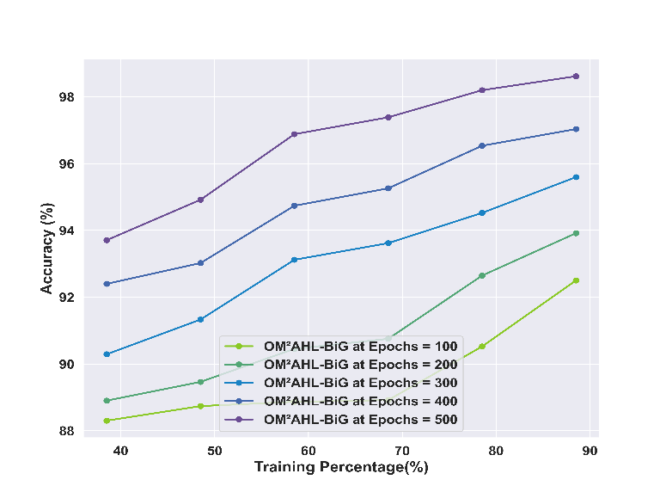 | 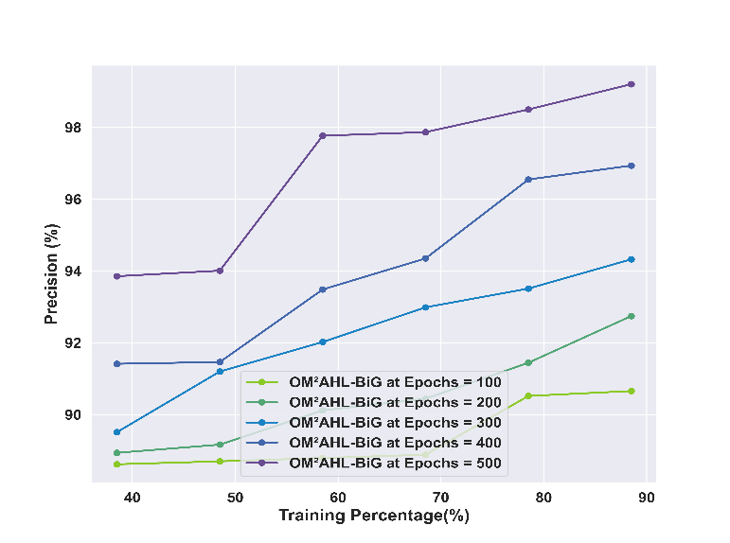
Accuracy | Precision
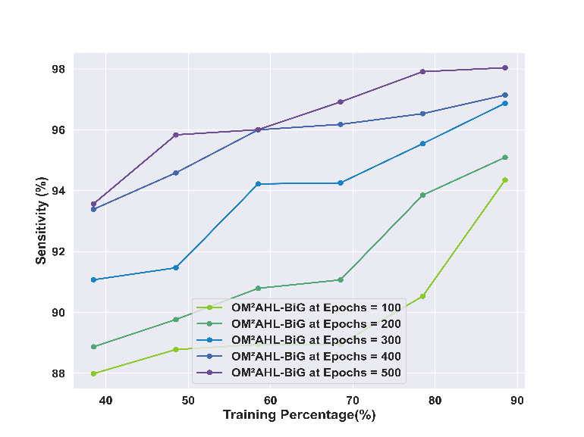 | 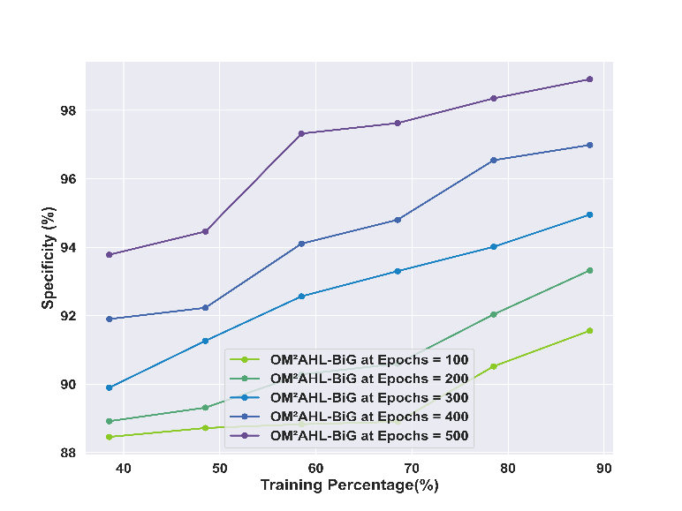
Sensitivity | Specificity
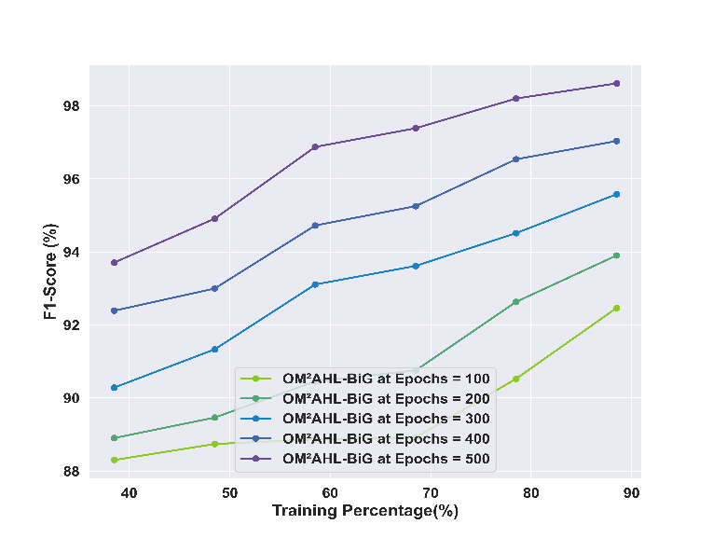
F1 Score
Figure 8. Performance Analysis based on Training Percentage
5.5.2 Evaluation of performance based on K-fold through the FaceForensics++ dataset
The proposed OM²AHL-BiG framework is examined for performance with the FaceForensics++ dataset, along 6 to 10 k-fold cross-validation with epochs 100 to 500, are displayed in Figure 9. It was observed that there was steady progress with all the metrics as the increase of epochs. With epoch 100, the model revealed an f 90.89% rate in accuracy, sensitivity of 91.49%, specificity of 90.59%, precision of 90.3%, and F1-score of 90.89%. By epoch 500, the performance increased to 97.28 % accuracy, 96.83% sensitivity, 97.5% specificity, 97.73% precision, and 97.27% F1-score. The model demonstrated stable and reliable performance across all folds, implying its robustness and generalizability in detecting forgery across varied manipulations.
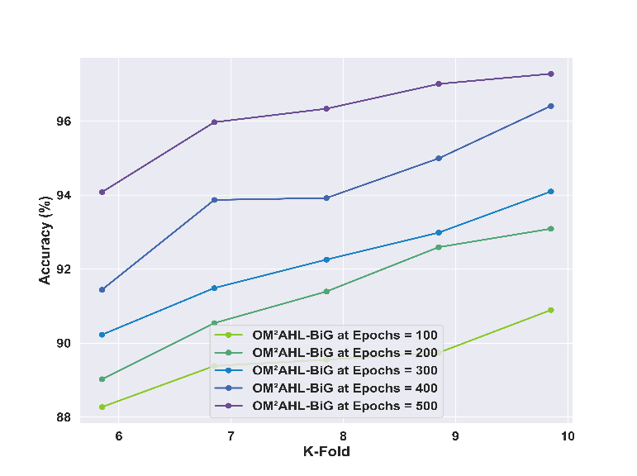 | 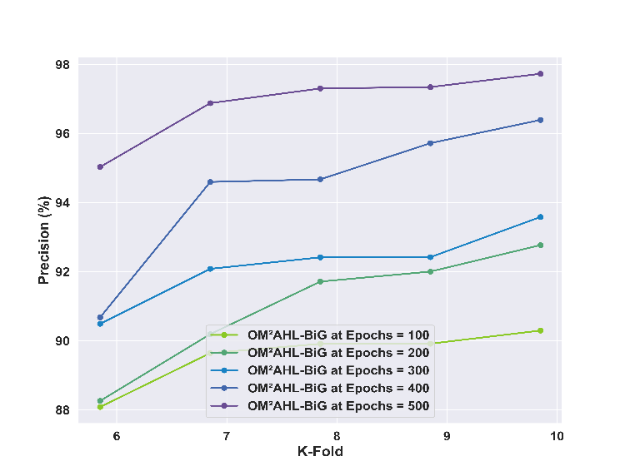
Accuracy | Precision
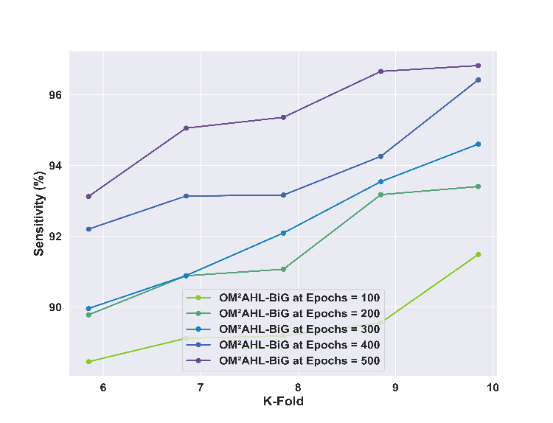 | 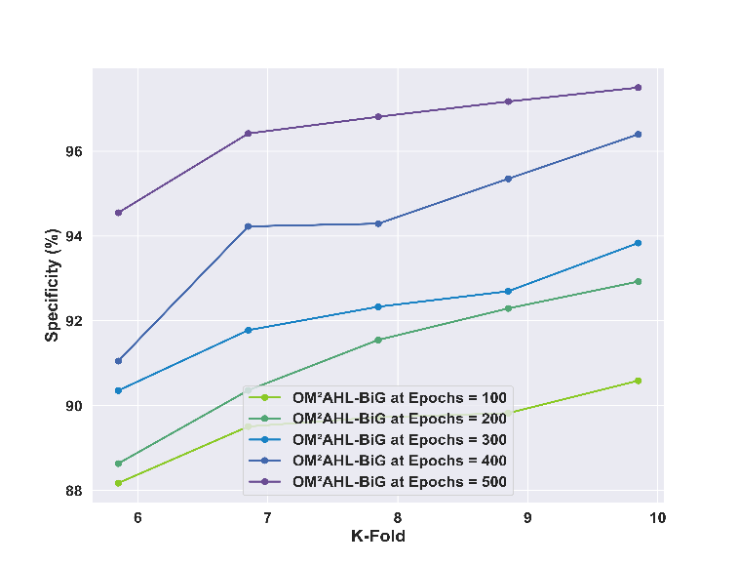
Sensitivity | Specificity
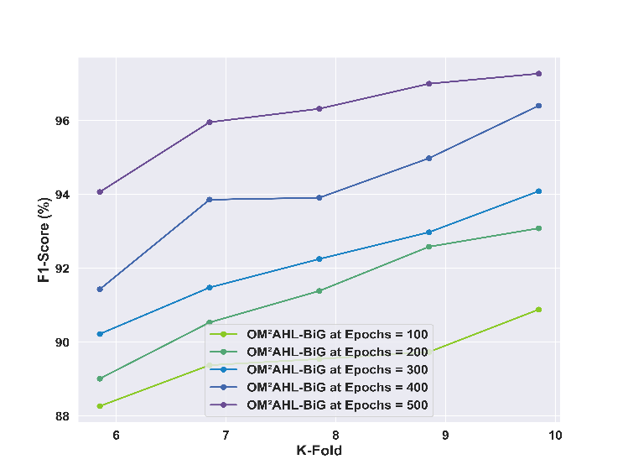
F1 Score
Figure 9. Performance Analysis based on K-fold Validation
5.6 Comparison Methods
The OM²AHL-BiG framework is compared against conventional approaches like STIDNet [1], BA-TFD [6], DCNN [2], GLCM [7], EfficientNet [5], Spatial-Channel Joint Attention coupled Convolutional distributed Long Short-Term Memory based Modified Pooling Network (SCAM-CLMPNet) [34], Parallel Multi-scale Attention coupled Convolutional distributed Long Short-Term Memory based Modified Pooling Network (MUSE-CLMPNet [35] and Spatial Multiscale Attention coupled Convolutional distributed Long Short-Term Memory based Modified Pooling Network (SMA-CLMPNet) to demonstrate the robust capabilities of the framework.
5.6.1 Evaluation of Comparison based on Training Percentage through FaceForensics++ dataset
Figure 10 portrays the comparative analysis of the OM²AHL-BiG model on the FaceForensics++ dataset over training epochs 100 to 500 and training percentages from 40% to 90%. While under successive training percentages, the OM²AHL-BiG demonstrates superior performance across accuracy, sensitivity, specificity, precision, and F1-score. Under 90% of training, the proposed OM²AHL-BiG attains a superior rate of 98.62% accuracy, while the STIDNet gained 97.71%, GLCM gained 94.64%, BA-TFD gained 96.69%, EfficientNet gained 97.35%, DCNN gained 97.48%, SCAM-CLMPNet gained 97.62%, MUSE-CLMPNet gained 97.7%, and SMA-CLMPNet gained 97.92% showcasing performance improvement. Similarly, for other measures, the other models showed performance drops while the OM2AHL-BiG attained 98.62% F1score, 99.2% precision, 98.04% sensitivity, and 98.91% specificity, confirming its effectiveness in detecting intra-frame forgeries.
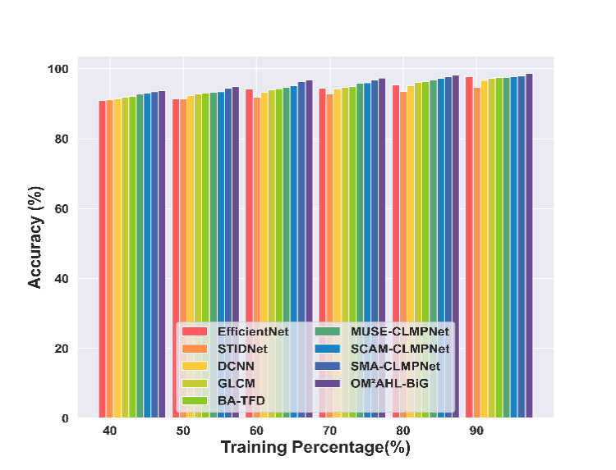 | 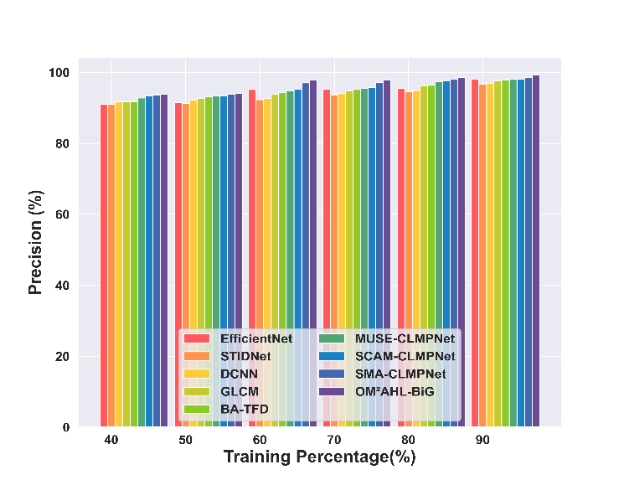
Accuracy | Precision
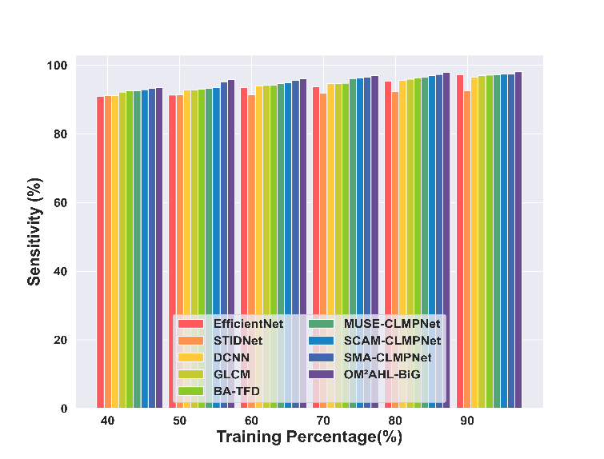 | 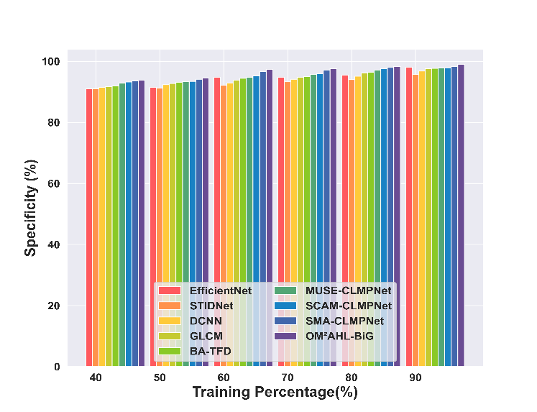
Sensitivity | Specificity
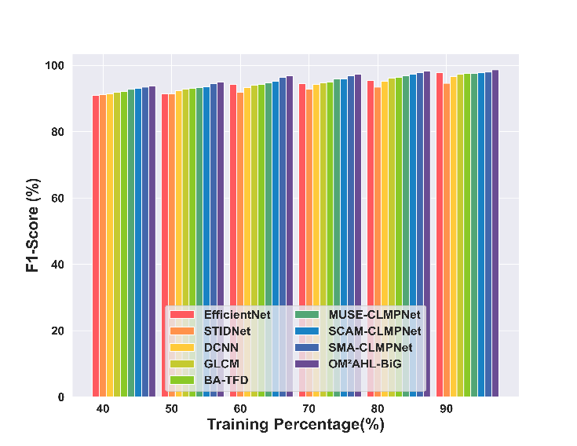
F1 Score
Figure 10. Comparative Assessment based on Training Percentage through FaceForensics++ dataset
5.6.2 Evaluation of Comparison based on K-fold through FaceForensics++ dataset
The comparison results based on the FaceForensics++ dataset under k-fold validation are depicted in Figure 11. The proposed OM²AHL-BiG framework consistently outperforms existing models across all evaluated metrics by achieving superior 97.28% accuracy, 97.73% precision, 96.83% sensitivity, 97.27% F1-score, and 97.5% specificity by gaining a marginal improvement of 2.16% with STIDNet, 2.04% with GLCM, 1.35% with BA-TFD, 1.24% with EfficientNet, 1.12% with DCNN, 0.72% with SCAM-CLMPNet, 0.42% with MUSE-CLMPNet, and 0.32% with SMA-CLMPNet in accuracy, ensuring consistent performance and generalization capability over diverse forgery types.
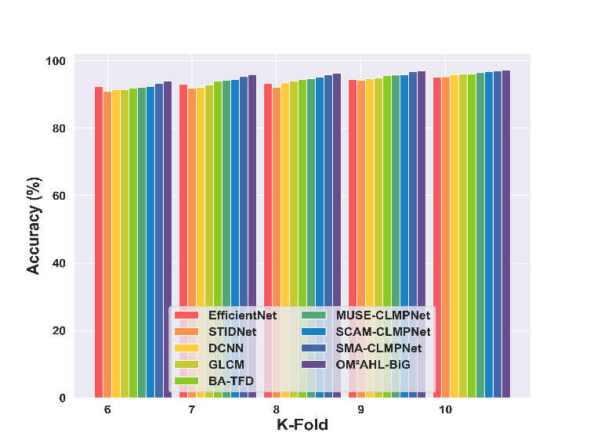 | 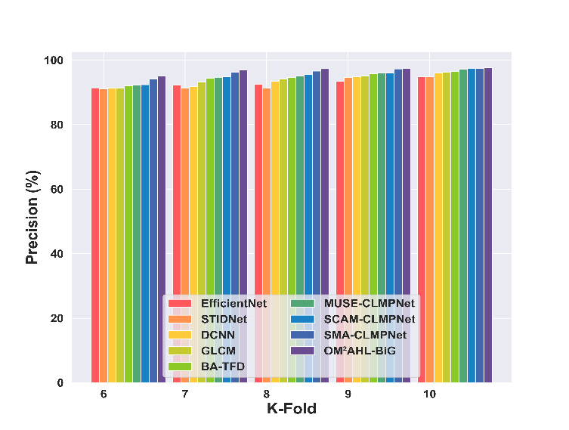
Accuracy | Precision
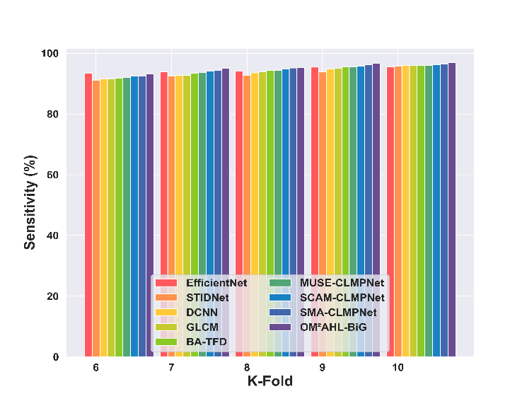 | 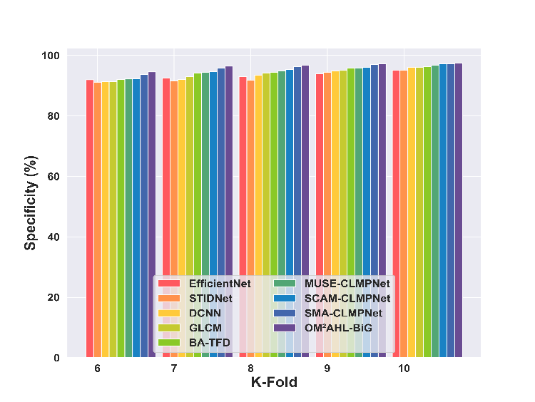
Sensitivity | Specificity
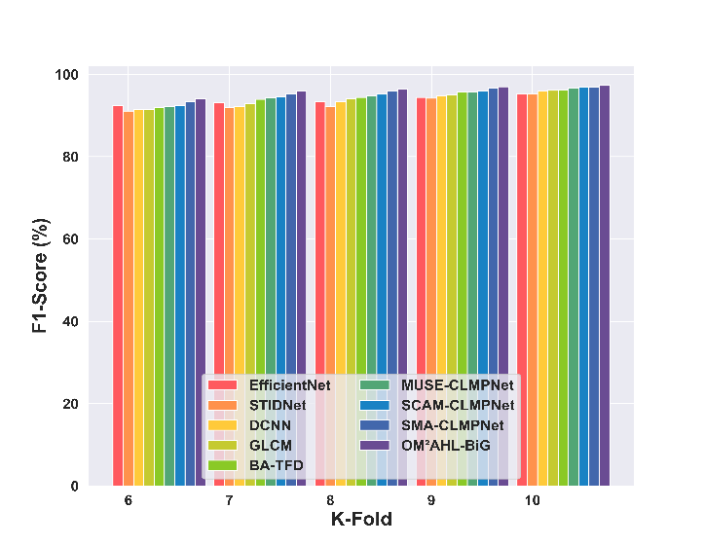
F1 Score
Figure 11. Comparative Assessment based on K-fold using FaceForensics++ dataset
5.7 Statistical Results
The statistical results attained by the OM²AHL-BiG model with different training percentages and k-fold are displayed in Tables 4,5. These results are attained under best, mean, variance, T-statistic, and P-value.
Table 4. Statistical Analysis based on Training percentage
Methods vs Attained Results |  |  |  | FaceForensics++ Dataset
 |  |  |  | Training Percent (90%)
 |  | EfficientNet | STIDNet |  | DCNN | GLCM | BA-TFD | MUSE-CLMPNet | SCAM-CLMPNet | SMA-CLMPNet | OM²AHL-BiG
Best | Accuracy (%) | 97.71 | 94.64 |  | 96.69 | 97.35 | 97.48 | 97.62 | 97.70 | 97.92 | 98.29
 | Precision (%) | 98.20 | 96.70 |  | 96.82 | 97.64 | 97.86 | 97.98 | 98.08 | 98.49 | 98.88
 | Sensitivity (%) | 97.22 | 92.57 |  | 96.57 | 97.07 | 97.09 | 97.25 | 97.33 | 97.34 | 97.70
 | Specificity (%) | 97.95 | 95.65 |  | 96.76 | 97.49 | 97.67 | 97.80 | 97.89 | 98.20 | 98.58
 | F1 Score (%) | 97.71 | 94.59 |  | 96.69 | 97.35 | 97.47 | 97.62 | 97.70 | 97.91 | 98.28
Mean | Accuracy (%) | 94.03 | 92.52 |  | 93.88 | 94.46 | 94.73 | 95.17 | 95.45 | 96.11 | 96.59
 | Precision (%) | 94.41 | 93.25 |  | 93.66 | 94.45 | 94.76 | 95.27 | 95.58 | 96.38 | 96.90
 | Sensitivity (%) | 93.65 | 91.79 |  | 94.10 | 94.47 | 94.69 | 95.06 | 95.32 | 95.85 | 96.29
 | Specificity (%) | 94.22 | 92.88 |  | 93.77 | 94.46 | 94.74 | 95.22 | 95.51 | 96.25 | 96.74
 | F1 Score (%) | 94.03 | 92.51 |  | 93.88 | 94.46 | 94.73 | 95.17 | 95.45 | 96.11 | 96.59
Variance | Accuracy (%) | 5.30 | 1.56 |  | 3.11 | 3.47 | 3.28 | 3.22 | 3.11 | 2.77 | 2.58
 | Precision (%) | 6.02 | 3.87 |  | 3.24 | 4.20 | 4.08 | 3.67 | 3.38 | 3.80 | 4.01
 | Sensitivity (%) | 4.82 | 0.30 |  | 3.17 | 2.81 | 2.62 | 2.90 | 2.93 | 2.09 | 1.65
 | Specificity (%) | 5.63 | 2.56 |  | 3.15 | 3.82 | 3.66 | 3.43 | 3.23 | 3.24 | 3.23
 | F1 Score (%) | 5.30 | 1.53 |  | 3.12 | 3.47 | 3.28 | 3.22 | 3.11 | 2.77 | 2.57
T-Statistic | Accuracy (%) | 2.95 | 2.57 |  | 3.15 | 3.06 | 3.21 | 3.07 | 2.98 | 3.63 | 3.94
 | Precision (%) | 3.06 | 2.49 |  | 2.54 | 3.06 | 3.42 | 2.90 | 2.76 | 3.20 | 3.61
 | Sensitivity (%) | 2.77 | 2.81 |  | 3.66 | 3.06 | 2.92 | 3.21 | 3.18 | 4.04 | 4.20
 | Specificity (%) | 3.01 | 2.53 |  | 2.85 | 3.06 | 3.32 | 2.99 | 2.87 | 3.41 | 3.77
 | F1 Score (%) | 2.95 | 2.58 |  | 3.15 | 3.06 | 3.21 | 3.07 | 2.98 | 3.63 | 3.94
P-Value | Accuracy (%) | 0.032 | 0.05 |  | 0.025 | 0.028 | 0.024 | 0.028 | 0.031 | 0.015 | 0.011
 | Precision (%) | 0.028 | 0.055 |  | 0.052 | 0.028 | 0.019 | 0.034 | 0.040 | 0.024 | 0.015
 | Sensitivity (%) | 0.039 | 0.038 |  | 0.015 | 0.028 | 0.033 | 0.024 | 0.025 | 0.010 | 0.008
 | Specificity (%) | 0.030 | 0.053 |  | 0.036 | 0.028 | 0.021 | 0.030 | 0.035 | 0.019 | 0.013
 | F1 Score (%) | 0.032 | 0.049 |  | 0.026 | 0.028 | 0.024 | 0.028 | 0.031 | 0.015 | 0.011
Table 5. Statistical Analysis based on K-fold Validation
 |  | FaceForensics++ dataset
 |  | K-fold Value= 10
 |  | EfficientNet | STIDNet | DCNN | GLCM | BA-TFD | MUSE-CLMPNet | SCAM-CLMPNet | SMA-CLMPNet | OM²AHL-BiG
Best | Accuracy (%) | 95.17 | 95.29 | 95.97 | 96.07 | 96.18 | 96.57 | 96.87 | 96.96 | 97.67
 | Precision (%) | 94.91 | 94.85 | 96.04 | 96.23 | 96.39 | 97.13 | 97.46 | 97.50 | 98.16
 | Sensitivity (%) | 95.43 | 95.74 | 95.89 | 95.92 | 95.98 | 96.02 | 96.28 | 96.43 | 97.18
 | Specificity (%) | 95.04 | 95.07 | 96.00 | 96.15 | 96.29 | 96.85 | 97.16 | 97.23 | 97.92
 | F1 Score (%) | 95.17 | 95.29 | 95.96 | 96.07 | 96.18 | 96.57 | 96.87 | 96.96 | 97.67
Mean | Accuracy (%) | 93.68 | 92.92 | 93.55 | 93.90 | 94.41 | 94.68 | 94.96 | 95.64 | 96.10
 | Precision (%) | 92.92 | 92.66 | 93.45 | 93.97 | 94.63 | 95.03 | 95.26 | 96.34 | 96.76
 | Sensitivity (%) | 94.44 | 93.17 | 93.66 | 93.82 | 94.19 | 94.33 | 94.66 | 94.93 | 95.44
 | Specificity (%) | 93.29 | 92.79 | 93.50 | 93.93 | 94.52 | 94.86 | 95.11 | 95.99 | 96.42
 | F1 Score (%) | 93.67 | 92.91 | 93.55 | 93.90 | 94.41 | 94.68 | 94.96 | 95.63 | 96.09
Variance | Accuracy (%) | 0.98 | 2.45 | 2.76 | 2.57 | 2.25 | 2.27 | 2.30 | 1.72 | 1.94
 | Precision (%) | 1.43 | 2.82 | 3.24 | 2.77 | 2.27 | 2.66 | 2.81 | 1.42 | 2.06
 | Sensitivity (%) | 0.67 | 2.40 | 2.35 | 2.41 | 2.25 | 1.95 | 1.88 | 2.06 | 1.86
 | Specificity (%) | 1.19 | 2.59 | 2.99 | 2.67 | 2.26 | 2.46 | 2.54 | 1.57 | 1.99
 | F1 Score (%) | 0.98 | 2.45 | 2.76 | 2.58 | 2.25 | 2.27 | 2.30 | 1.73 | 1.94
T-Statistic | Accuracy (%) | 2.53 | 2.36 | 2.61 | 3.02 | 3.36 | 3.35 | 3.39 | 3.56 | 3.55
 | Precision (%) | 2.48 | 1.89 | 2.45 | 3.16 | 3.45 | 3.44 | 3.44 | 3.66 | 3.62
 | Sensitivity (%) | 2.50 | 2.72 | 2.78 | 2.86 | 3.25 | 3.22 | 3.30 | 3.46 | 3.45
 | Specificity (%) | 2.51 | 2.13 | 2.53 | 3.09 | 3.41 | 3.40 | 3.42 | 3.61 | 3.59
 | F1 Score (%) | 2.53 | 2.35 | 2.61 | 3.02 | 3.36 | 3.35 | 3.39 | 3.56 | 3.55
P-Value | Accuracy (%) | 0.064 | 0.078 | 0.060 | 0.039 | 0.028 | 0.028 | 0.028 | 0.024 | 0.024
 | Precision (%) | 0.068 | 0.132 | 0.070 | 0.034 | 0.026 | 0.026 | 0.026 | 0.021 | 0.022
 | Sensitivity (%) | 0.067 | 0.053 | 0.050 | 0.046 | 0.031 | 0.032 | 0.030 | 0.026 | 0.026
 | Specificity (%) | 0.066 | 0.101 | 0.065 | 0.036 | 0.027 | 0.027 | 0.027 | 0.023 | 0.023
 | F1 Score (%) | 0.064 | 0.078 | 0.060 | 0.039 | 0.028 | 0.028 | 0.028 | 0.024 | 0.024

5.8 ROC Analysis
The ROC analysis of the OM²AHL-BiG framework is presented in Figure 12. The graph reveals a high true positive and minimal false positives, indicating strong capability in accurately distinguishing between normal and scam video frames against other existing methods.
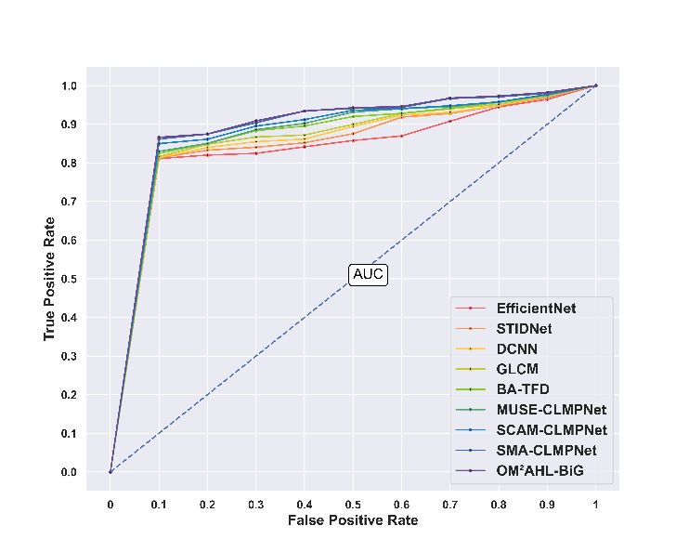

Figure 12. ROC Analysis
5.9 Confusion Matrix
Figure 13. displays the confusion matrix analysis on the FaceForensics++ dataset. The confusion matrix provides a concise overview of the detection system's performance across the Normal and Scam classes, comparing the predicted labels against the actual ones to assess detection accuracy.
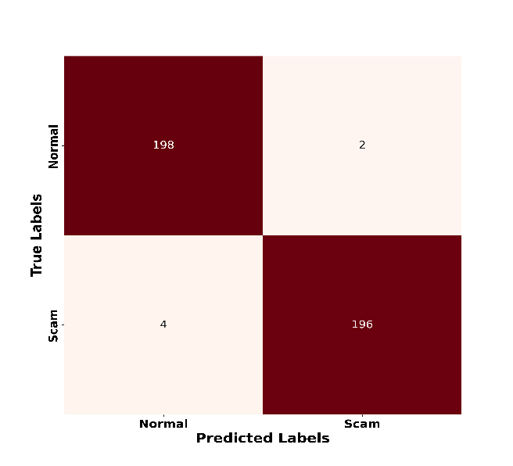

Figure 13. Confusion Matrix
5.10 Convergence Analysis
Figure 14. depicts the analysis of convergence rate based on the FaceForensics++ dataset is analyzed across epochs. For epoch 20, the BES attains a convergence of 0.484, HHO attains 0.002, and the proposed OM²AHL-BiG attained 0.001, showcasing its proficiency against individual algorithms.
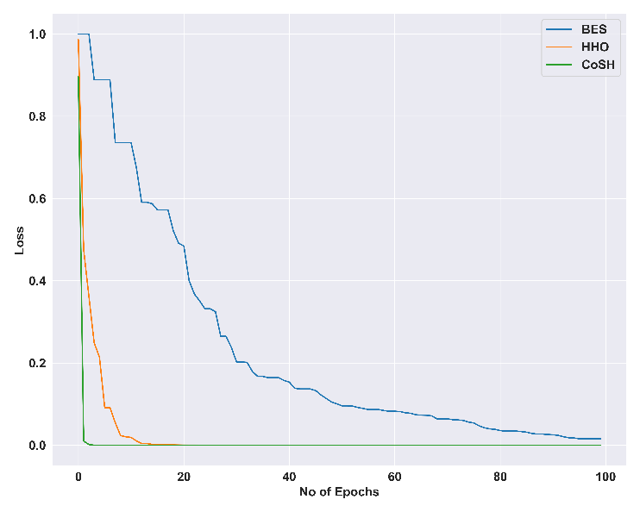

Figure 14. Convergence Analysis
5.11 Computation Time Analysis
The analysis of computation time across the epoch counts is presented in Figure 15. For the highest epochs 100, STIDNet needs 334.83s, GLCM needs 329.96s, BA-TFD needs 330.55s, EfficientNet needs 331.69s, DCNN needs 332.36s, SCAM-CLMPNet needs 333.79s, MUSE-CLMPNet needs 334.03s, and SMA-CLMPNet needs 334.07s, while the proposed OM²AHL-BiG needs 321.8s, which is far better than the existing methods.
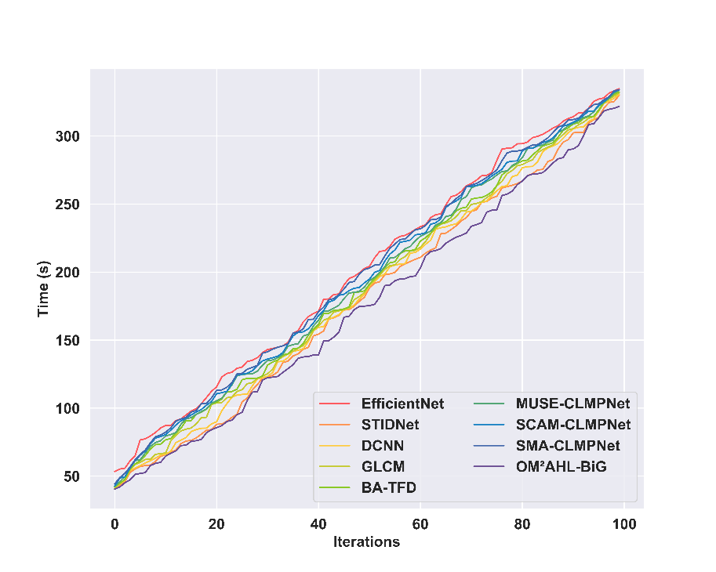

Figure 15. Analysis of Computational Time
5.12 Comparative Discussion
To validate the effectiveness of the proposed video forgery detection framework, a comprehensive comparative analysis is conducted with traditional methods. The traditional methods like the STIDNet [2] show encouraging performance in detecting identity-specific facial forgeries, but it faces challenges related to completely exploiting extraction models to build highly discriminative features, which restricts its robustness against a wide range of forgery techniques. The DCNN-based method [3] can generalize to identify a variety of patterns within the video data, but fails to identify the specific locations that have been tampered with, particularly in videos that are of low resolution or have been compressed. While the EfficientNet [5], though advanced in detecting deepfake content, exhibits poor generalization, making it challenging to differentiate between authentic and high-quality forged faces, which results in increased misclassification. The GLCM technique [7] used for detecting duplicate frames failed to show the same robustness when dealing with inter-frame insertion or deletion of frames, which causes increased false positive and negative detection rates. Meanwhile, BA-TFD strategy [6] utilizes audio reenactment for forgery detection on high-resolution materials, which leads to lower performance and higher costs of computation. The MUSE-CLMPNet [34], SCAM-CLMPNet [35], and the SMA-CLMPNet, due to the absence of efficient feature learning and poor discrimination of subtle forgery cues, ultimately reduce the accuracy. The following limitations are effortlessly handled by the proposed OM²AHL-BiG framework that leverages hybrid learning techniques for improved feature representation, multi-level mixed attention for refinement of features, and BiLSTM for long-range temporal relationships, and GBM enhances the classification performance through an iterative sequence of decision trees. These combined benefits provide a promising solution for detecting intra-frame video forgeries. Table 6 highlights the comparative discussion on the performance obtained by the proposed OM²AHL-BiG against conventional techniques.
Table 6. Comparative Discussion Table of the OM2AHL-BiG framework
 |  | Face Forensics++ Dataset
 |  | EfficientNet | STIDNet | DCNN | GLCM | BA-TFD | MUSE-CLMPNet | SCAM-CLMPNet | SMA-CLMPNet | OM²AHL-BiG
Training Percentage (90%) | Accuracy (%) | 97.71 | 94.64 | 96.69 | 97.35 | 97.48 | 97.62 | 97.70 | 97.92 | 98.62
 | Precision (%) | 98.20 | 96.70 | 96.82 | 97.64 | 97.86 | 97.98 | 98.08 | 98.49 | 99.20
 | Sensitivity (%) | 97.22 | 92.57 | 96.57 | 97.07 | 97.09 | 97.25 | 97.33 | 97.34 | 98.04
 | Specificity (%) | 97.95 | 95.65 | 96.76 | 97.49 | 97.67 | 97.80 | 97.89 | 98.20 | 98.91
 | F1 Score (%) | 97.71 | 94.59 | 96.69 | 97.35 | 97.47 | 97.62 | 97.70 | 97.91 | 98.62
K-Fold (10) | Accuracy (%) | 95.17 | 95.29 | 95.97 | 96.07 | 96.18 | 96.57 | 96.87 | 96.96 | 97.28
 | Precision (%) | 94.91 | 94.85 | 96.04 | 96.23 | 96.39 | 97.13 | 97.46 | 97.50 | 97.73
 | Sensitivity (%) | 95.43 | 95.74 | 95.89 | 95.92 | 95.98 | 96.02 | 96.28 | 96.43 | 96.83
 | Specificity (%) | 95.04 | 95.07 | 96.00 | 96.15 | 96.29 | 96.85 | 97.16 | 97.23 | 97.50
 | F1 Score (%) | 95.17 | 95.29 | 95.96 | 96.07 | 96.18 | 96.57 | 96.87 | 96.96 | 97.27

The smoke-scale re-evaluation confirms that the OM2AHL-BiG training stack (feature load from Features.pkl, class-balanced train_test_split, Network.BiLSTMGBM with five incremental learning chunks, GradientBoostingClassifier head, and Evaluation_Metrics) executes end-to-end on the shipped FaceForensics++ feature set (199 videos; 99 authentic / 100 forged). Absolute accuracy is lower than Table 6 because the re-run uses only 3 epochs per incremental chunk and disables CoSH weight optimization (mealpy HYBRID with population 50), whereas the published numbers use 500 epochs with CoSH. Therefore Table 7 is a pipeline validation result, not a claim that supersedes Tables 4-6. A browser demo of the same conceptual stages (upload, ROI, attention map, statistical maps, keypoints, shape, verdict) is provided under webapp/ for Render deployment, while full training remains offline.
Table 7. Smoke-scale re-evaluation of OM2AHL-BiG (BiLSTMGBM) on Features.pkl
Training % | Accuracy (%) | Sensitivity (%) | Specificity (%) | Precision (%) | F1 Score (%)
40% | 95.00 | 93.33 | 96.67 | 96.55 | 94.92
50% | 91.00 | 90.00 | 92.00 | 91.84 | 90.91
60% | 83.75 | 80.00 | 87.50 | 86.49 | 83.12
70% | 88.33 | 90.00 | 86.67 | 87.10 | 88.52
80% | 95.00 | 95.00 | 95.00 | 95.00 | 95.00
Table 7 summarizes the smoke-scale re-run of the proposed OM2AHL-BiG classifier (Network.BiLSTMGBM in SubFunctions/Model.py) over training percentages 40%-90% on the pre-extracted FaceForensics++ feature tensor Features/Features.pkl with shape (199, 15, 32, 32, 10). Each split uses the same train_test_split routine as TPAnalysis.ComparativeAnalysis. Training used 3 epochs per incremental-learning chunk (five cumulative chunks), batch size 32, Adam optimizer, and CoSH / mealpy weight optimization disabled for wall-clock feasibility on CPU. The published paper configuration uses 500 epochs with CoSH enabled (estimated multi-day CPU runtime). Outputs were written to Analysis1/TP/COM_A_eval.npy and driver_out/evaluation_tp_ep3.txt without overwriting the published Analysis/ arrays that drive Figures 8-15.
5.13 Implementation Re-evaluation and Deployment Notes
6. Conclusion
The research designs a proposed OM²AHL-BiG approach for detecting the intra-frame forgery traces. The architecture leverages the Hybrid learning strategy for improved feature representation, BiLSTM for capturing temporal dependencies, and GBM for precise classification. Additionally, the attention mechanisms allow effective discrimination of abstractive features required for analysis, and the CoSH optimization used for optimizing hyperparameters leads to enhanced performance in detecting forged frames. The adaptive key frame selection and the Viola Jones-for ROI extraction strategy enable to extraction of important facial regions along with the robust feature extraction process to capture intricate forgery patterns. The framework ultimately classifies test frames as normal or scam, demonstrating its effectiveness in current video forgery detection scenarios. This OM²AHL-BiG approach leads to enhanced discriminability, better generalization across manipulation types, and improved robustness in detecting forgery in varied video conditions. During performance validation on the Face Forensics ++ dataset, the framework obtains a 98.62% accuracy, 99.2% precision, 98.62% specificity, 98.04% sensitivity, and 98.62% F1score while tested on the training percentage of 90% replicating its proficiency against other existing methods. Moreover, the extended works of the framework should focus on implementing strategies for feature selection to ensure marginal features for analysis, thereby leading to enhanced computational efficiency and more precise outcomes in identity-aware face forgery detection.
References
[1] Fang, M., Yu, L., Xie, H., Tan, Q., Tan, Z., Hussain, A., Wang, Z., Li, J. and Tian, Z., 2024. STIDNet: Identity-aware face forgery detection with spatiotemporal knowledge distillation. IEEE Transactions on Computational Social Systems, 11(4), pp.5354-5366.
[2] Mazhar, A.A., Jameel, A., Nadeem, M., Khan, M.A., Alkhateeb, J.H., Bibi, F. and Seerat, A.M., 2024. Deep convolutional neural network for robust detection of object-based forgeries in advanced video. IEEE Access, 12, pp.21156-21164.
[3] Liu, Q. and Xue, Z., 2023. Local corner and motion key point trajectory extraction for facial forgery identification. Security and Communication Networks, 2023(1), p.1648912.
[4] Bozkurt, I. and Ulutas, G., 2023. Detection and localization of frame duplication using binary image template. Multimedia Tools and Applications, 82(20), pp.31001-31034.
[5] Zhang, D., Chen, J., Liao, X., Li, F., Chen, J. and Yang, G., 2024. Face forgery detection via multi-feature fusion and local enhancement. IEEE Transactions on Circuits and Systems for Video Technology, 34(9), pp.8972-8977.
[6] Cai, Z., Ghosh, S., Dhall, A., Gedeon, T., Stefanov, K. and Hayat, M., 2023. Glitch in the matrix: A large-scale benchmark for content driven audio–visual forgery detection and localization. Computer Vision and Image Understanding, 236, p.103818.
[7] Li, L., Lu, J., Zhang, S., Mohaisen, L. and Emam, M., 2023. Frame duplication forgery detection in surveillance video sequences using textural features. Electronics, 12(22), p.4597.
[8] Bao, Q., Wang, Y., Hua, H., Dong, K. and Lee, F., 2024. An anti-forensics video forgery detection method based on noise transfer matrix analysis. Sensors, 24(16), p.5341.
[9] Ali, M.M., Ghali, N.I., Hamza, H.M., Hosny, K.M., Vrochidou, E. and Papakostas, G.A., 2025. Interframe Forgery Video Detection: Datasets, Methods, Challenges, and Search Directions. Electronics, 14(13), p.2680.
[10] Shelke, M.P., Ranjan, N., Kharade, A., Gaikwad, P., Arakh, S. and Kalore, A., 2023. Combining computer vision techniques and intraframe noise methods to detect a deepfake.
[11] Patel, Y., Tanwar, S., Gupta, R., Bhattacharya, P., Davidson, I.E., Nyameko, R., Aluvala, S. and Vimal, V., 2023. Deepfake generation and detection: Case study and challenges. IEEE Access, 11, pp.143296-143323.
[12] Nguyen, T.D., Fang, S. and Stamm, M.C., 2024. Videofact: detecting video forgeries using attention, scene context, and forensic traces. In Proceedings of the IEEE/CVF winter conference on applications of computer vision (pp. 8563-8573).
[13] Singh, L.H., Charanarur, P. and Chaudhary, N.K., 2025. Advancements in detecting Deepfakes: AI algorithms and future prospects− a review. Discover Internet of Things, 5(1), p.53.
[14] Ren, H., Atwa, W., Zhang, H., Muhammad, S. and Emam, M., 2021. Frame duplication forgery detection and localization algorithm based on the improved Levenshtein distance. Scientific Programming, 2021(1), p.5595850.
[15] Wu, N., Jin, X., Jiang, Q., Wang, P., Zhang, Y., Yao, S. and Zhou, W., 2022. Multisemantic path neural network for deepfake detection. Security and Communication Networks, 2022(1), p.4976848.
[16] Kaur, S., Kumar, P. and Kumaraguru, P., 2020. Deepfakes: temporal sequential analysis to detect face-swapped video clips using convolutional long short-term memory. Journal of electronic imaging, 29(3), p.033013.
[17] Yu, P., Xia, Z., Fei, J. and Lu, Y., 2021. A survey on deepfake video detection. Iet Biometrics, 10(6), pp.607-624.
[18] Guo, Y., Xu, Q., Sun, S., Luo, X. and Sbert, M., 2016. Selecting video key frames based on relative entropy and the extreme studentized deviate test. Entropy, 18(3), p.73.
[19] Chaudhari, M.N., Deshmukh, M., Ramrakhiani, G. and Parvatikar, R., 2018, August. Face detection using viola jones algorithm and neural networks. In 2018 Fourth International Conference on Computing Communication Control and Automation (ICCUBEA) (pp. 1-6). IEEE.
[20] Selvaraju, R.R., Cogswell, M., Das, A., Vedantam, R., Parikh, D. and Batra, D., 2020. Grad-CAM: visual explanations from deep networks via gradient-based localization. International journal of computer vision, 128, pp.336-359.
[21] Haloi, R., Hazarika, J. and Chanda, D., 2020, July. Selection of appropriate statistical features of EEG signals for detection of Parkinson’s disease. In 2020 International Conference on Computational Performance Evaluation (ComPE) (pp. 761-764). IEEE.
[22] Fejer, A., Nagy, Z., Benois‐Pineau, J., Szolgay, P., de Rugy, A. and Domenger, J.P., 2021. Implementation of Scale Invariant Feature Transform detector on FPGA for low‐power wearable devices for prostheses control. International Journal of Circuit Theory and Applications, 49(7), pp.2255-2273.
[23] Sekehravani, E.A., Babulak, E. and Masoodi, M., 2020. Implementing canny edge detection algorithm for noisy image. Bulletin of Electrical Engineering and Informatics, 9(4), pp.1404-1410.
[24] Luo, Y., Yin, L., Bai, W. and Mao, K., 2020. An appraisal of incremental learning methods. Entropy, 22(11), p.1190.
[25] Hameed, Z. and Garcia-Zapirain, B., 2020. Sentiment classification using a single-layered BiLSTM model. Ieee Access, 8, pp.73992-74001.
[26] Wang, Q., Qian, X., Fu, Y. and Xue, X., 2022. Co-attention aligned mutual cross-attention for cloth-changing person re-identification. In Proceedings of the Asian conference on computer vision (pp. 2270-2288).
[27] Shen, X., Han, D., Chen, C., Luo, G. and Wu, Z., 2022. An effective spatial relational reasoning networks for visual question answering. Plos one, 17(11), p.e0277693.
[28] Woo, S., Park, J., Lee, J.Y. and Kweon, I.S., 2018. Cbam: Convolutional block attention module. In Proceedings of the European conference on computer vision (ECCV) (pp. 3-19).
[29] Ai, Q., Hill, D.N., Vishwanathan, S.V.N. and Croft, W.B., 2019, November. A zero attention model for personalized product search. In Proceedings of the 28th ACM International Conference on Information and Knowledge Management (pp. 379-388).
[30] FaceForensics++ Dataset, “https://www.niessnerlab.org/projects/roessler2019faceforensicspp.html”, accessed on July,2025.
[31] Su, Y., 2020, April. Prediction of air quality based on Gradient Boosting Machine Method. In 2020 International Conference on Big Data and Informatization Education (ICBDIE) (pp. 395-397). IEEE.
[32] Alsattar, H.A., Zaidan, A.A. and Zaidan, B.B., 2020. Novel meta-heuristic bald eagle search optimisation algorithm. Artificial Intelligence Review, 53(3), pp.2237-2264.
[33] Shehab, M., Mashal, I., Momani, Z., Shambour, M.K.Y., AL-Badareen, A., Al-Dabet, S., Bataina, N., Alsoud, A.R. and Abualigah, L., 2022. Harris hawks optimization algorithm: variants and applications. Archives of Computational Methods in Engineering, 29(7), pp.5579-5603.
[34] Fang, W. and Han, X.H., 2020. Spatial and channel attention modulated network for medical image segmentation. In Proceedings of the Asian conference on computer vision.
[35] Yao, L., Wang, J. and Zhao, C., 2024. Non-Intrusive Load Monitoring Based on Multiscale Attention Mechanisms. Energies, 17(8), p.1944.

